Paper for Data Mining Project

**Introduction:**

The goal of this project was to build and test various classifier models on a part of the 2018 BRFSS Survey Data prepared by the CDC to choose the best model that provided the best classification performance. For this purpose, I divided the entire dataset into both training and test datasets (training dataset took up 66% of the data, test dataset took up remaining 34%). I then used 5 different attribute selection methods based on the class attribute havarth3 to obtain reduced training datasets and reduced test datasets. Using JMP Pro, I then trained 5 different classifier models for each attribute selection method against each reduced training dataset (25 in total). These trained classifiers were then used on each of the reduced training datasets to see which of these models best predicted the class of the reduced test datasets.

**Preprocessing Performed on Dataset:**

Before I split the data into test and train datasets, I performed some data preprocessing on the *weight2, children, sleptim1, htin4 and physhlth* attributes. For each of these attributes, I removed the question mark symbols indicating missing data and replaced any data points indicating refusal to provide information (usually represented by 9999 or 99) or not knowing the answer to a question (usually represented by 7777 or 77) with missing values. This recording resulted in the creation of new columns, titled *weight2 2, children2, sleptim1 2, htin4 2,* and *physhlth2*. I then transformed these variables in continuous, numeric variables, where JMP used “.” to indicate missing values. For each attribute, I replaced each of the missing values created or already present in this new column with the value of the mean of that column (*weight2 2 =* 180.80, *children2* = 0.518, *sleptim1 2* = 7.027, *Htin4 2*= 66.944, *physhlth2* = 4.337). After this, I examined each column for outliers. In the case of *htin4 2* and *physhlth2*, there were none, so no more preprocessing was required. However, for the *children*2 and *sleptim1* *2* attributes, I noticed the presence of several outliers. To deal with this issue, I used equal-width binning partitioning to create binning formulas (W = B-A/N) for each attribute. For *children2*, I used 5 bins of width 2 (10-0 =10/5 = 2) and for *sleptim1* 2, I used 11 bins of width 2 (23-1 = 22/11 = 2). This created two new columns titled *children2 binned* and *sleptim1 2 binned* (later changed name to *sleptim1 binned*). Then, I smoothed each of these bins using bin medians.For *weight2 2*, I noticed that some weights were reported in kilograms (kg’s) and some were reported in pounds (lbs). To create one centralized measure for this column, I created a new column called *Weight (in lbs)* which used a formula to transform the weights given in kg’s to lbs. As a final step, I turned the class variable (*havarth3*) into nominal character variable. I then deleted the original columns (*weight2, children, sleptim1, htin4* and *physhlth*) and replaced them with these new preprocessed columns (*Weight (in lbs), chlidren2 binned, sleptim1 binned, htin4 2, and physhlth2*).

**Attribute Selection Methods Used:**

After this splitting the data into test and train datasets, I used 5 different attribute selection methods to select different attributes to subset the test and train data by to created reduced test and reduced train datasets. The 5 attribute selection methods I chose were the OneR, Correlation, ReliefF, Cfs Subset, and Gain Ratio attribute evaluators. The OneR attribute evaluator evaluates the worth of an attribute by using the OneR classifier, which examines each attribute in the training dataset and calculates the error rate based on how well said attribute can predict the class labels. The Correlation attribute evaluator examines the worth of an attribute by measuring the Pearson correlation coefficient between each attribute in the dataset and the class attribute. The attribute pairs with the highest absolute correlation coefficient are then selected as the most useful predictors and the Correlation attribute evaluator returns these attributes ranked in order from the highest to the lowest. The attribute with the lowest error rate is selected as the best predictor. The ReliefF attribute evaluator works by calculating the "relief" of each attribute, which is a measure of how well the attribute can distinguish between different classes in the dataset. The attributes with the highest relief scores are considered the most important and are selected for use in the final machine learning model. The Cfs Subset evaluator evaluates the worth of a subset of attributes by considering the individual predictive ability of each feature along with the degree of redundancy between them. It does this by using a technique called correlation-based feature selection to evaluate the performance of different subsets of features. Finally, the Gain Ratio attribute evaluator measures the worth of an attribute by measuring the gain ratio with respect to the class attribute. Gain ratio is a measure of how much the attribute reduces the info (or entropy) of the class variable and, therefore, how well it can predict the class variable.

**List of Attributes Selected by Each Method Employed:**

The 10 attributes that were selected via the OneR evaluator were *diffwalk, employ1, physhlth 2, genhlth, x.rfhlth, x.phys14d, chccopd1, diffalon, x.ageg5yr,* and *rmvteth4*. The 10 attributes that were selected using the Correlation Attribute Evaluator were *x.age80, x.age.g, diffwalk, x.ageg5yr, genhlth, x.hcvu651, physhlth 2, x.age65yr, pneuvac4*, and *employ1*. The 10 attributes that were selected by the ReliefF attribute evaluator were *marital, employ1, x.age.g, height3, htm4, diffwalk, renthom1, x.age80, x.ageg5yr* and *x.race.g1.* The 10 attributes that were selected using the Cfs Subset evaluator were employ1, deaf, pneuvac4, diffwalk, diabete3, physhlth2, persdoc2, chccopd1, x.age.g and x.age80. Finally, the 10 attributes selected using the Gain Ratio evaulator were diffwalk, chccopd1, x.rfhlth, diffdres, x.age65yr, diffalon, x.age80, x.age.g, employ1 & x.ageg5yr.

**Classifier Algorithms Used:**

The 5 classifier algorithms that I used in this project were the decision tree, naïve bayes, K-Nearest Neighbors, Logistic Regression, and Support Vector Machine algorithms. Decision trees are an algorithm that work by dividing the input space into regions, where each region is associated with a specific class. These regions are created by using a set of decision rules that are learned from a provided training dataset. The decision rules are represented as a tree-like structure, where the internal nodes of the tree represent the decision rules and the leaves of the tree represent the final classes predicted by the model. The decision tree algorithm starts at the root node of the tree and applies decision rules at each node to determine which branch to follow. This process continues until a leaf node is reached, at which point the algorithm outputs the predicted class for the input variable. The naïve bayes algorithm is based on Bayes Theorem, which states that the probability of an event occurring can be calculated by considering the prior probabilities of each class and the likelihood of a certain tuple belonging to each class. In the case of the naive Bayes algorithm, the input space is divided into regions, where each region is associated with a specific class. The algorithm then calculates the probability of a tuple belonging to each class based on the prior probabilities of the classes and the likelihood of the tuple belonging to each class. The class with the highest probability is then predicted as the output for the input example. Naive Bayes is called naive because it assumes that all the attributes in the input data are independent of each other. K-Nearest Neighbors, or KNN for short, is a Lazy Learner because it does not build a model from a training dataset. Instead, it stores a training dataset to classify new tuples when they are entered. KNN predicts the class label of a new tuple by the class labels of the k nearest neighbor tuples in the stored training dataset by majority voting and the predicted output for the new tuple is the average of the outputs of the tuple’s k-nearest neighbors. Logistic Regression is a classification algorithm that works by learning a set of weights from a training dataset that are used to make predictions for new tuples in said dataset. These weights are learned by optimizing an objective function that measures the accuracy of the model on the training data. For multi-class classification tasks, multiple logistic regression models can be trained, one for each class. Finally, Support Vector Machines (SVM’s) are used to find linear decision boundaries called hyperplanes with the largest margins of linearly separable data. The tuples that fall on the side of these hyperplanes are called support vectors. SVM’s can find linearly separating hyperplanes for even non-linearly separable data by transforming data to a higher dimensional space.

**Best Model Results:**

Out of the 25 models that I produced for this project, the one that returned the best results was the Nominal Logistic Regression model based on Correlation attribute evaluator. The attributes that were used in the best training dataset, as gathered in Weka, were:

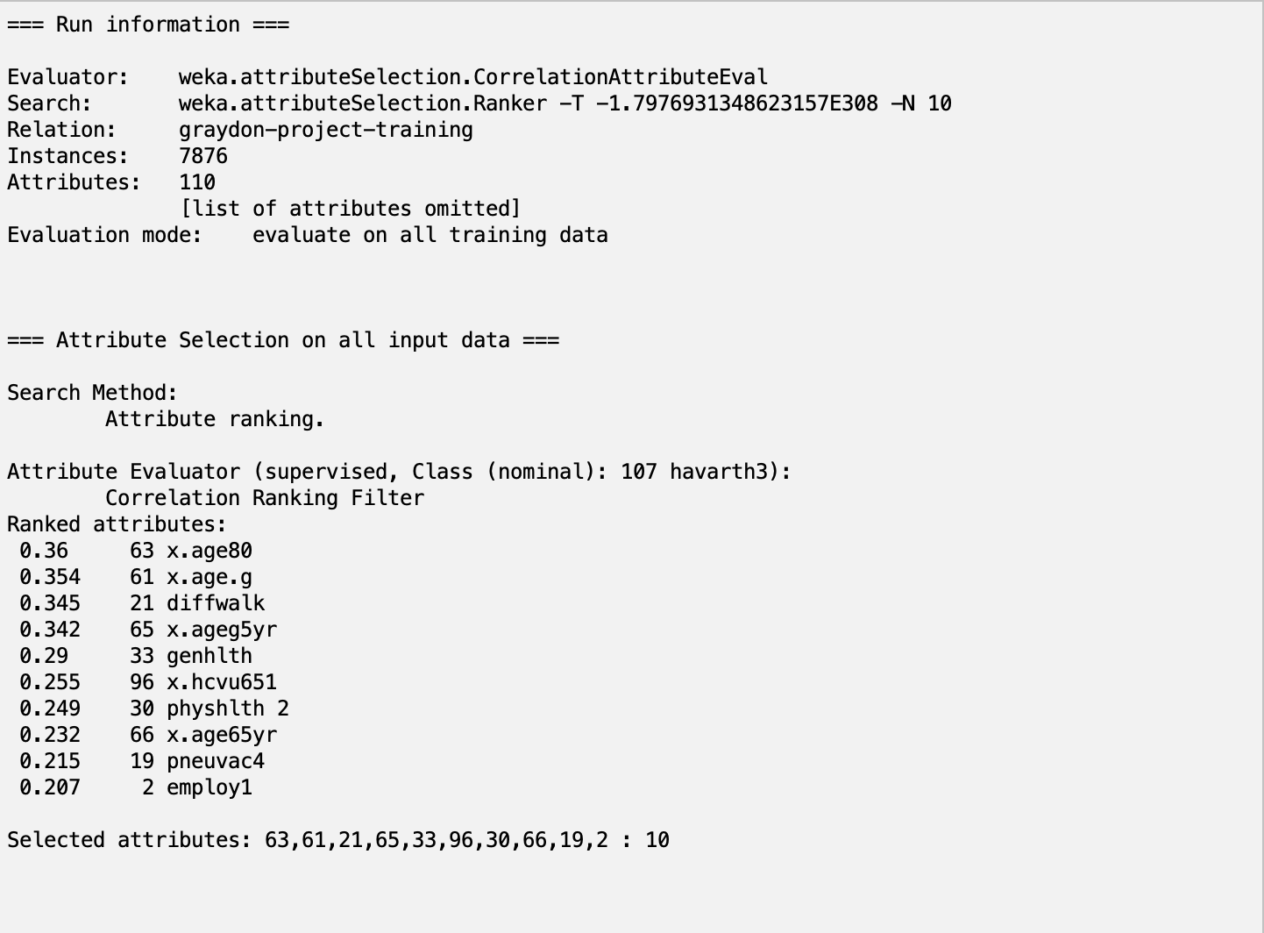

The best test result I received from JMP are shown below:

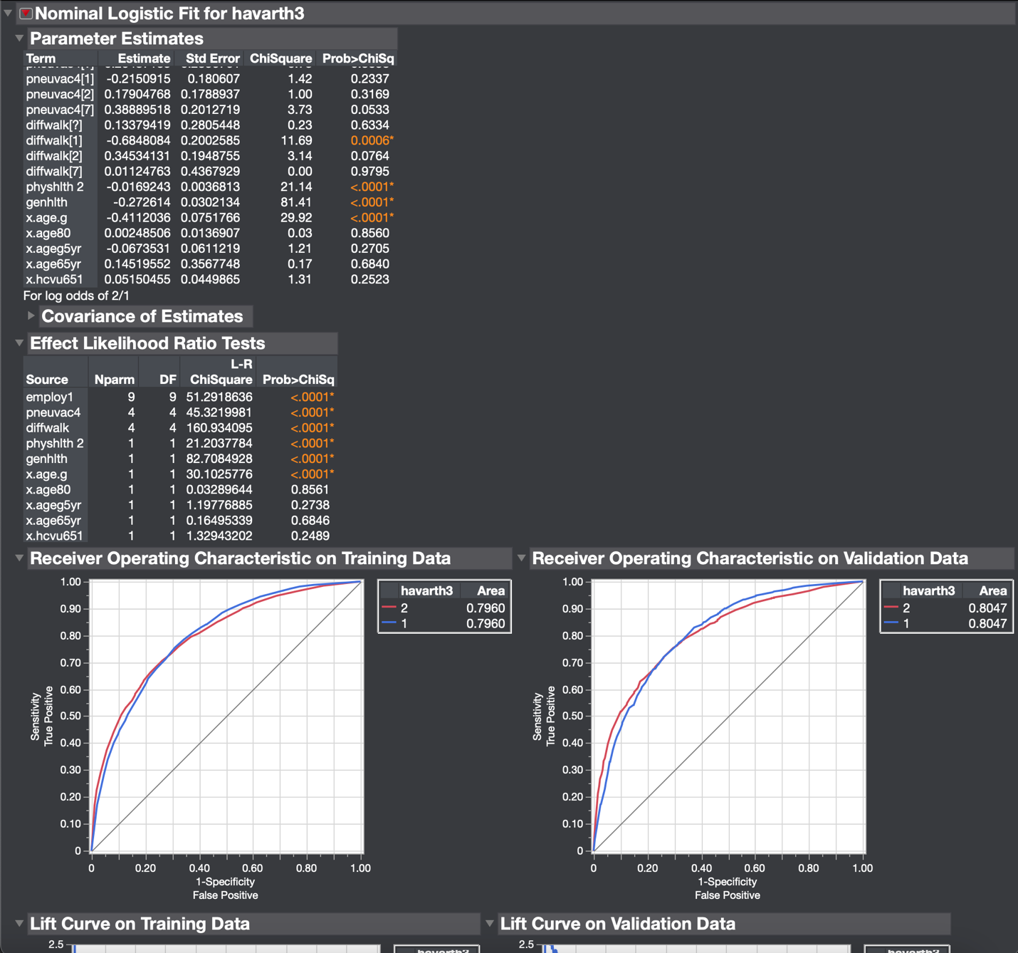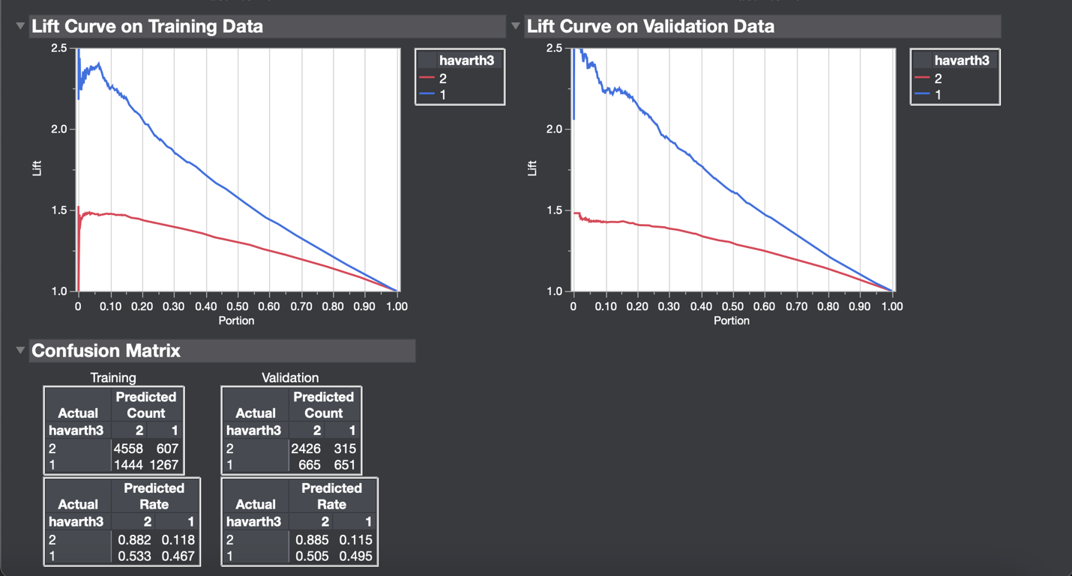

For class 1, the True Positive rate is 0.495. The weighted true positive rate for class 1 is about 0.1606. The true positive rate for Class 2 is 0.885. The weighted true positive rate for class 2 is about 0.5979. The weighted true positive rate for both classes is about 0.7585. The false positive rate for class 1 is 0.115. The weighted false positive rate for class 1 is about 0.0373. The false positive rate for class 2 is 0.5053. The weighted false positive rate for class 2 is about 0.3414. The weighted average false positive rate for both classes is about 0.3787. The precision for class 1 is 0.2116. The weighted precision for class 1 is 0.0686. The precision for class 2 is 0.7848. The weighted precision for class 2 is 0.5302. The total weighted precision for both classes is 0.5989. The recall for class 1 is equal to the True Positive rate, which is 0.495. This means it’s average weighted recall is the same as well (0.1606). The recall for class 2 is equal to the True Positive rate, which 0.885. This means that it’s weighted average recall is the same as well (0.5979). Therefore, the weighted is the same as it was for true positive rate (0.7585). The F-measure of class 1 is 0.2965. The weighted F-measure of class 1 is 0.0961. The F-measure for class 2 is 0.8318. The weighted F-measure for class 2 is 0.5619. The weighted F-measure for both classes is 0.6582. The MCC for class 1 is 0.4174. The weighted MCC for class 1 is 0.1344. The MCC of class 2 is also 0.4174. The weighted MCC for class 2 is 0.2820. The weighted MCC for both classes is 0.4174. Finally, the weighted ROC area for class 1 is 0.2610. The weighted ROC area for class 2 is 0.5437. The combined weighted ROC area for both classes is 0.8047.

**Discussion:**

The criteria I used for this project to choose my best model were mainly metrics of fit, such as those provided in the fit details section of JMP Pro. These metrics include Entropy R^2, Generalized R^2, Mean -Log p, RASE, Mean Absolute Deviation and Misclassification rate. I also used the area under the ROC curve and the resulting confusion matrixes to make decisions on which model was the best. The reason why I chose the above model as my best model is because it maxed out all the parameters described above. In other words, this nominal logistic model produced the highest Entropy and Generalized R-squared values, the smallest Mean -Log p value, the smallest RASE value, the smallest Mean Absolute Deviation value, and the smallest Misclassification Rate. Not only this, but this model also had the largest area under the ROC curve and resulted in the highest number of correct class label predictions for both classes out of the models employed.

The five attributes that I think are the most relevant to the class attribute (havarth3), based on the models I used, are employ1, diffwalk, x.age.g, x.ageg5yr and x.age80. This is because out of the 5 attribute selection methods I used, these attributes were the ones that got chosen repeatedly the most. For example, employ1 is an attribute that shows up in every reduced test and train set I created because of this project. The same can be said for the diffwalk attribute, which is also chosen by all 5 attribute selection methods. Meanwhile, x.age.g, x.ageg5yr and x.age80 are all picked by 4 out of the 5 attribute selection methods. These repeated selections, especially given the fact that I primarily used attribute selection methods with evaluated potential predictor attributes based on rank, must mean that these attributes (specifically employ1 and diffwalk) are very good predictors of the havarth3 class labels.

After finishing this project, I had a couple of interesting takeaways. Most notably, I learned from this process how to use JMP Pro to properly test classifiers and how some models take a longer time to run than others, such as SVM’s. I also learned that optimizing model data on a training dataset is a series of trial and error. In other words, the default settings for each of these classifiers in JMP Pro won’t return the best result right away. You must play around with these settings to figure out how to optimize a classifier on a training dataset before you can apply it to the test dataset, which can be a long process. I also learned how helpful Weka is in terms of selecting attributes to create reduced test and train datasets. Finally, I learned that there are many different ways that you can evaluate a classifier model, each of which can yield effective results in their own unique ways.

In terms of other observations noted during this project, I noticed a pattern in where the Naïve Bayes algorithm typically yielded the worst results as the R-squared, Mean -Log p and RASE values combined with a high misclassification rate indicated that these models typically yielded poor model fits and end results. One interesting instance of the Naïve Bayes algorithm was the model based on the OneR attribute selection method. This algorithm produced an Entropy R-squared value of -0.872 and had a generalized R-squared value of -2.793. This indicates a very poor model fit, which is echoed further by a high Mean -Log p of 1.1796, a high RASE value, and a misclassification rate that is the worst for the OneR attribute evaluator. However, the mean absolute deviation was decent for this model and the area under the ROC curve also wasn’t bad and both conveyed more reasonable fits, which I found very interesting because they contrasted the results reported by the R-squared values. Additionally, I learned that Nominal Logistic regression was the classification method that generally performed the best. This is because the metrics mentioned above were maxed out typically for each attribute selection method employed. Some other things Another interesting thing that I noticed throughout the course of this project was that the models based on SVM’s typically did not have the most accurate results. For example, the SVM based on gain ratio only had a low entropy R-squared value and generalized R-squared value, high Mean -Log p value, RASE, mean absolute deviation and misclassification rate, all which state that this model is not a very good fit. Based on what we learned in class about SVM’s, I assumed this would have been one of the more accurate models that would present a better fit for the data since we touched on one of its benefits as how accurate it is. As it turns out though, this wasn’t the case, which was a very interesting result. The same could be said for all the other SVM models as well, which also weren’t very accurate compared to most of the other models employed.

**Appendix:**

Results obtained using OneR attribute evaluator and Nominal Logistic Regression:

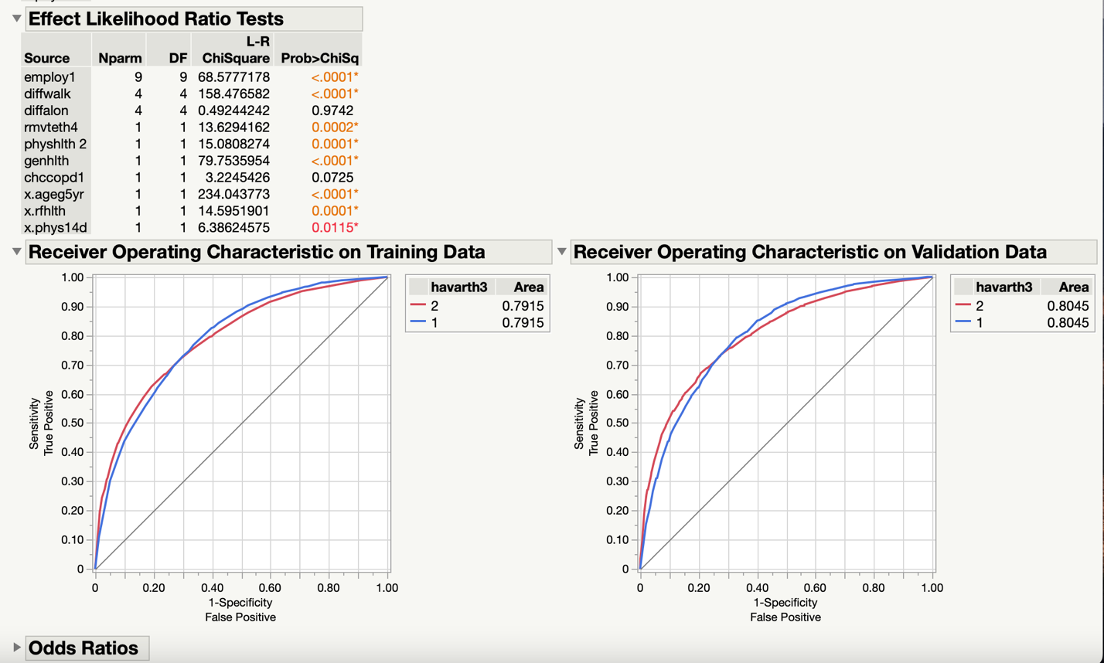

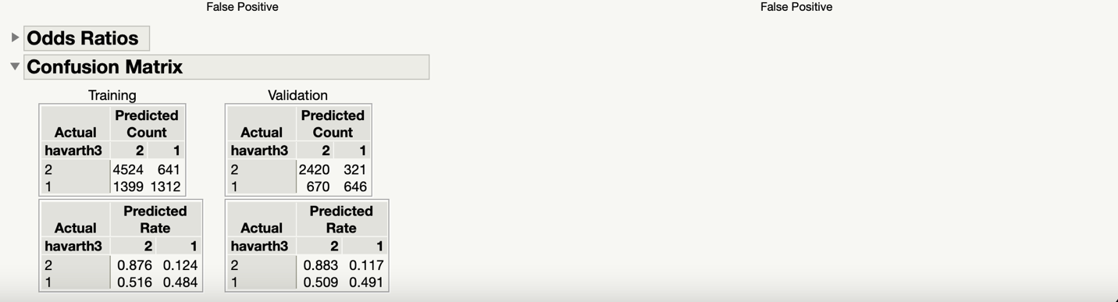

Class 1 TPR = 0.4908. Weighted average TPR for Class 1 = 0.1592. Class 2 TPR = 0.8829. Weighted average TPR for class 2 = 0.5965. Weighted combined average TPR for both classes =0.7557. FPR for class 1 = 0.117. Weighted average FPR for class 1 = 0.0686. FPR for class 2 = 0.5091. Weighted average FPR for class 2 = 0.3439. Weighted combined average FPR for both classes = 0.3819. Precision for class 1 = 0.6680. Weighted average precision for class 1 = 0.2167. Precision for class 2= 0.7832. Weighted average precision for class 2 = 0.5291. Weighted combined average precision for both classes = 0.7458. Recall for class 1 = TPR. Recall for class 2 = TPR. Weighted averages across all classes = same as TPR for Recall. F-measure of class 1 = 0.5658. Weighted average F-measure for class 1= 0.1835. F-measure for class 2= 0.8301. Weighted average F-measure for class 2 = 0.5608. Weighted combined average F-measure for both classes = 0.7443. MCC for class1 = 0.4106. Weighted average MCC for class 1 = 0.1332. MCC of class 2 = 0.4106. Weighted average MCC for class 2 = 0.2774. Weighted combined average MCC for both classes = 0.4106. Weighted average ROC area for class 1 = 0.2610. Weighted average ROC area for class 2 = 0.5435. Weighted combined average ROC area for both classes = 0.8045.

Results Obtained using OneR Attribute Evaluator and Decision Tree Algorithm:

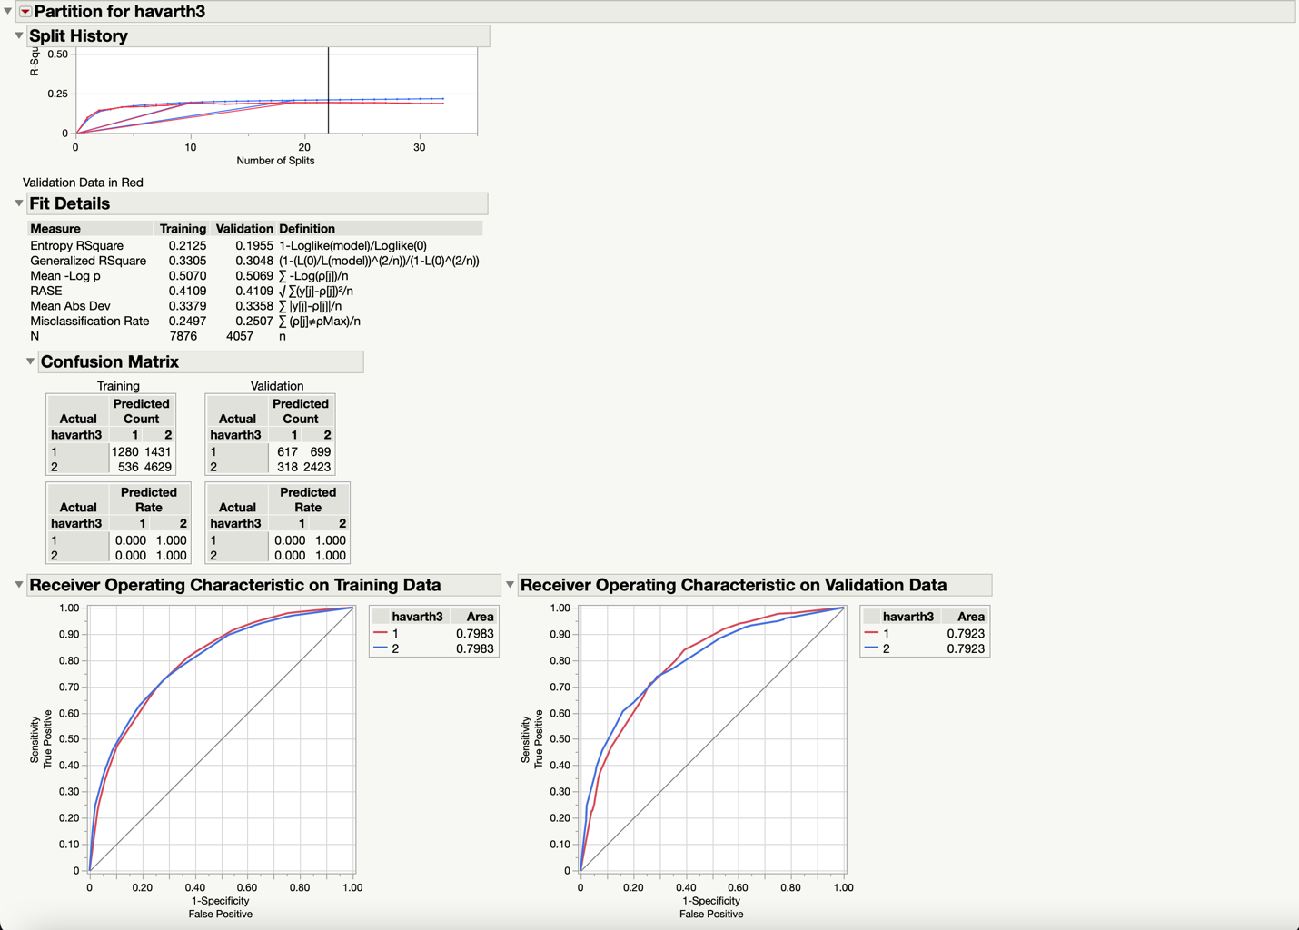

Class 1 TPR = 0.4688. Weighted average TPR for Class 1 = 0.1521. Class 2 TPR = 0.8840. Weighted average TPR for class 2 = 0.5972. Weighted combined average TPR for both classes =0.7493. FPR for class 1 = 0.1160. Weighted average FPR for class 1 = 0.0376. FPR for class 2 = 0.5311. Weighted average FPR for class 2 = 0.3589. Weighted combined average FPR for both classes =0.3965. Precision for class 1 = 0.6600. Weighted average precision for class 1 = 0.2140. Precision for class 2= 0.7761. Weighted average precision for class 2 = 0.5243. Weighted combined average precision for both classes = 0.7384. Recall for class 1 = TPR. Recall for class 2 = TPR. Weighted averages across all classes = same as TPR for Recall. F-measure of class 1 = 0.5482. Weighted average F-measure for class 1= 0.1778. F-measure for class 2= 0.8265. Weighted average F-measure for class 2 = 0.5584. Weighted combined average F-measure for both classes = 0.7362. MCC for class1 = 0.3922. Weighted average MCC for class 1 = 0.1272. MCC of class 2 = 0.3922. Weighted average MCC for class 2 = 0.2650. Weighted combined average MCC for both classes = 0.3922. Weighted average ROC area for class 1 = 0.2570. Weighted average ROC area for class 2 = 0.5353. Weighted combined average ROC area for both classes = 0.7923.

Results Obtained from using OneR Attribute Evaluator and K Nearest Neighbors Algorithm:

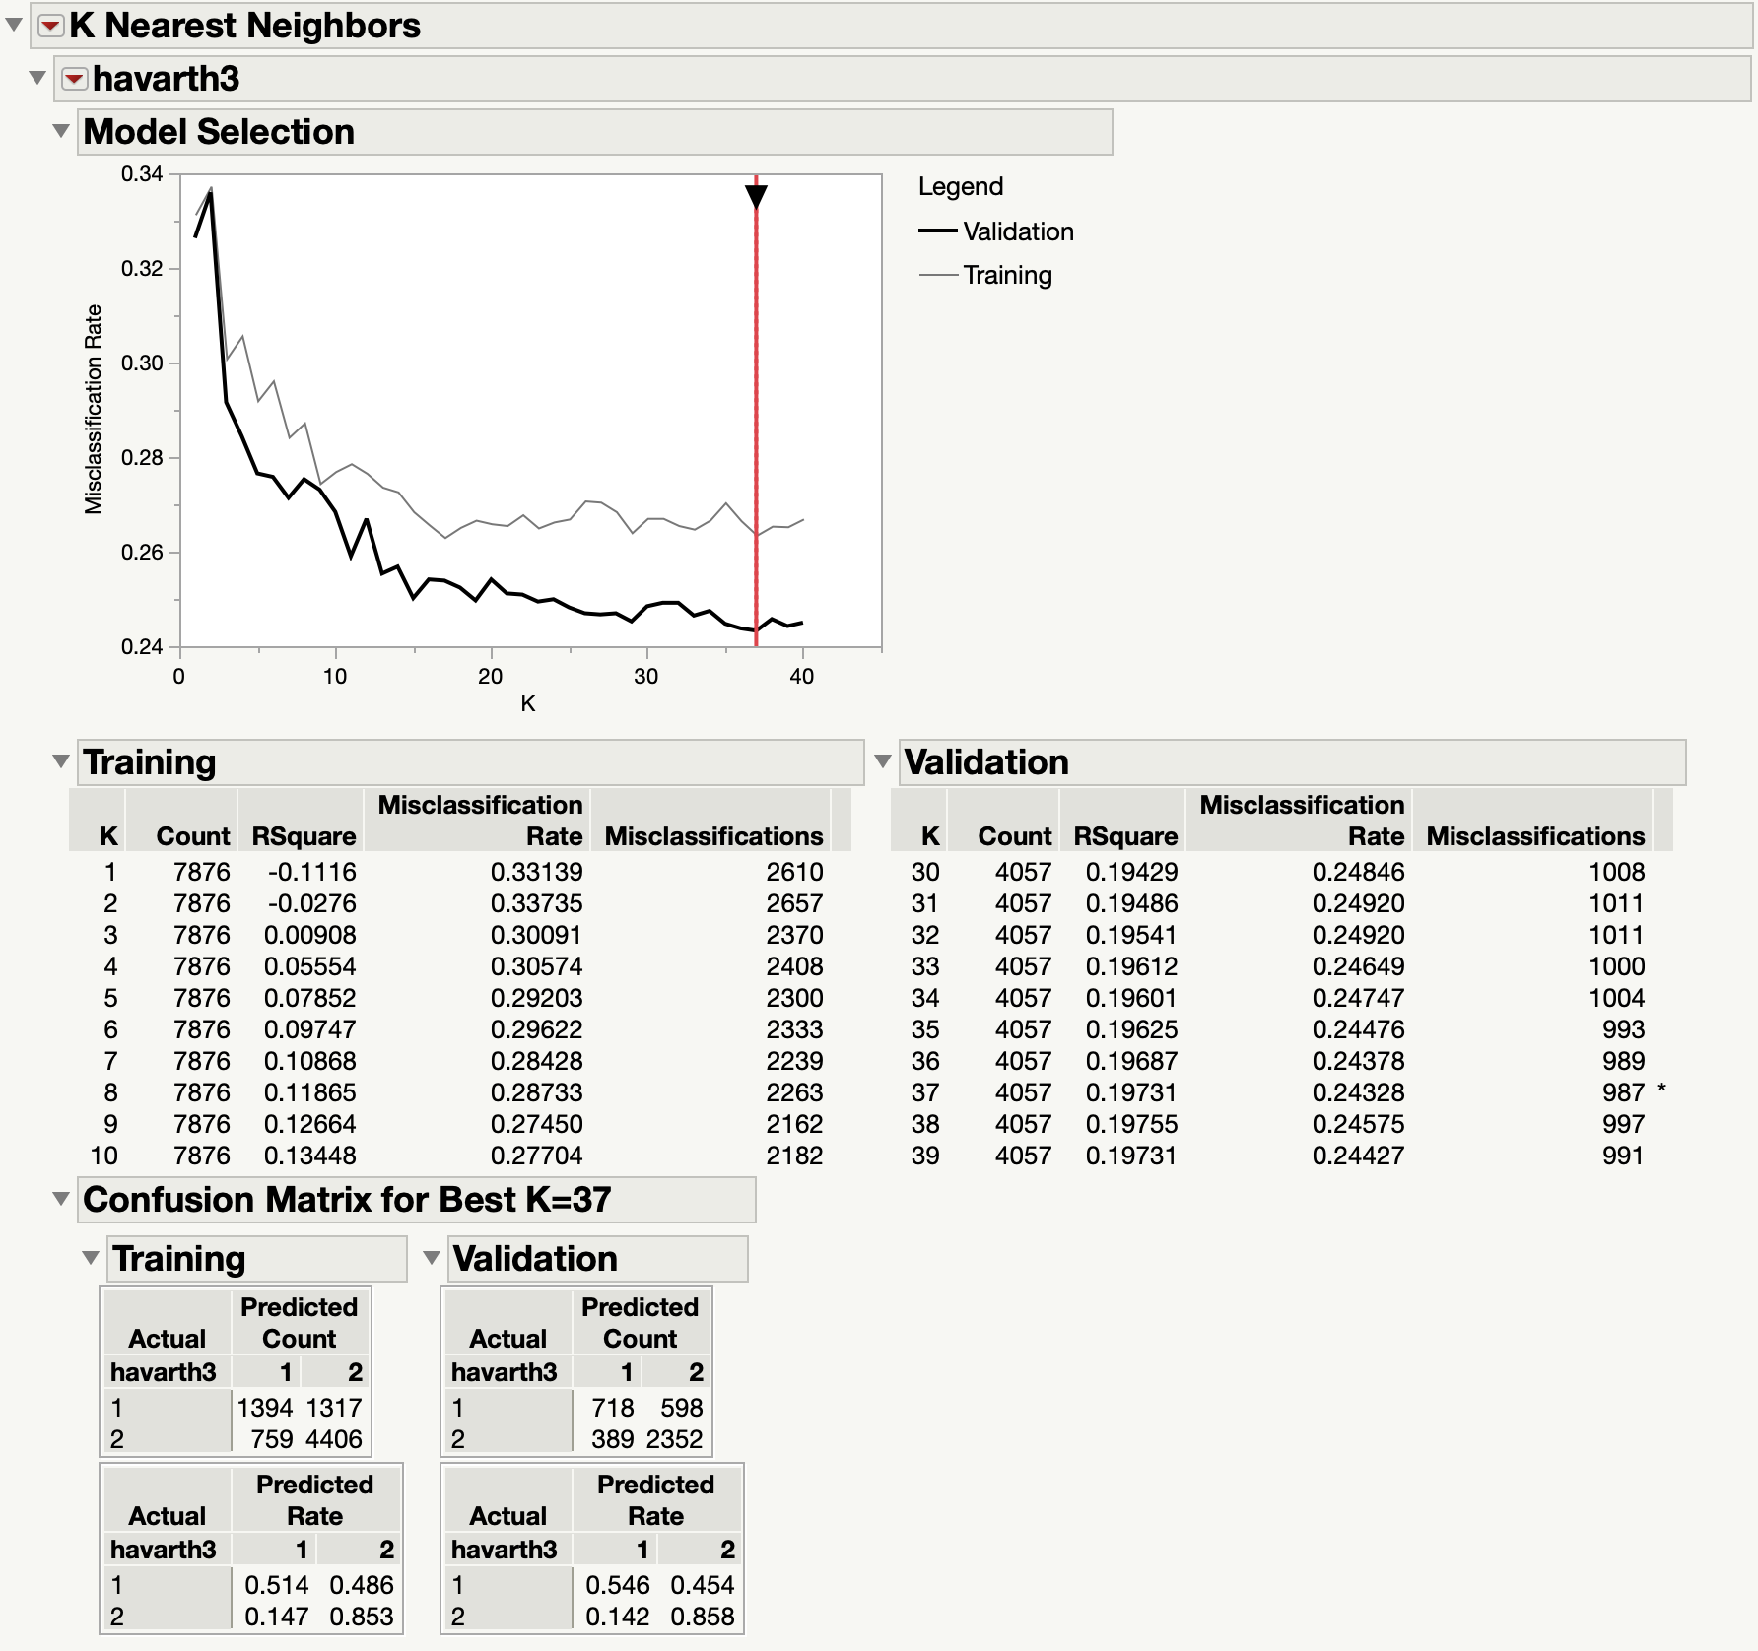

Class 1 TPR = 0.5456. Weighted average TPR for Class 1 = 0.1770. Class 2 TPR = 0.8581. Weighted average TPR for class 2 = 0.5797. Weighted combined average TPR for both classes =0.7567. FPR for class 1 = 0.1420. Weighted average FPR for class 1 = 0.0460. FPR for class 2 = 0.4544. Weighted average FPR for class 2 = 0.3070. Weighted combined average FPR for both classes =0.3530. Precision for class 1 = 0.6486. Weighted average precision for class 1 = 0.2104. Precision for class 2= 0.7973. Weighted average precision for class 2 = 0.7490. Weighted combined average precision for both classes = 0.7490. Recall for class 1 = TPR. Recall for class 2 = TPR. Weighted averages across all classes = same as TPR for Recall. F-measure of class 1 = 0.5926. Weighted average F-measure for class 1= 0.1922. F-measure for class 2= 0.8266. Weighted average F-measure for class 2 = 0.5584. Weighted combined average F-measure for both classes = 0.7507. MCC for class1 = 0.4242. Weighted average MCC for class 1 = 0.1376. MCC of class 2 = 0.4242. Weighted average MCC for class 2 = 0.2866. Weighted combined average MCC for both classes = 0.4242. K Nearest Neighbors does not include ROC curve option on JMP Pro.

Results Obtained using OneR Attribute Evaluator and Naïve Bayes Algorithm:

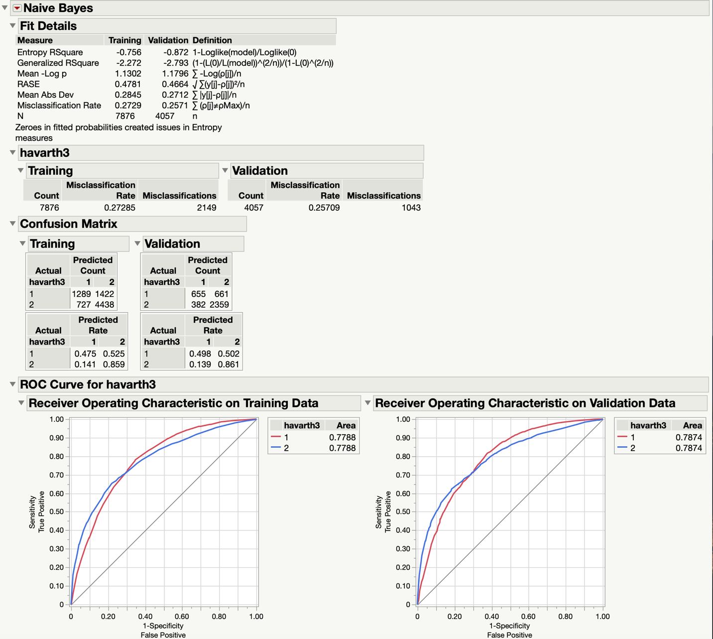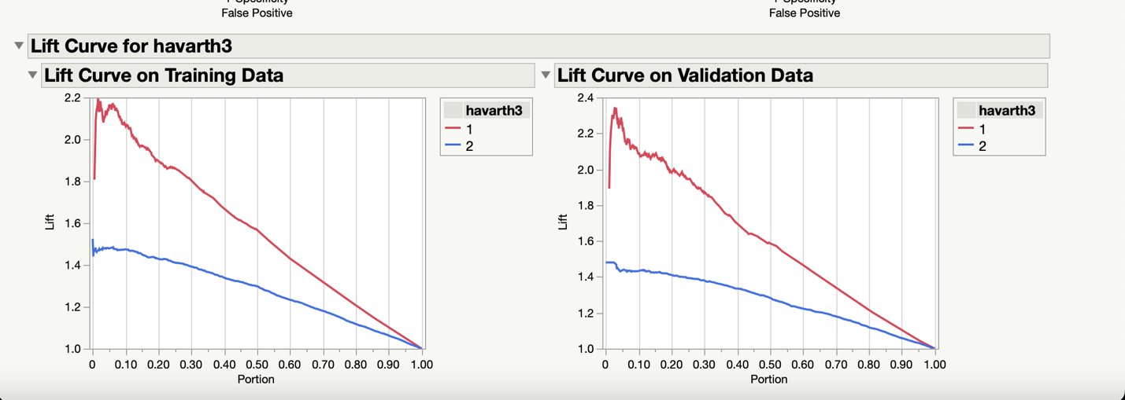

Class 1 TPR = 0.4977. Weighted average TPR for Class 1 = 0.1614. Class 2 TPR = 0.8606. Weighted average TPR for class 2 = 0.5815. Weighted combined average TPR for both classes =0.7429. FPR for class 1 = 0.1393. Weighted average FPR for class 1 = 0.0452. FPR for class 2 = 0.5023. Weighted average FPR for class 2 = 0.3393. Weighted combined average FPR for both classes =0.3845. Precision for class 1 = 0.6316. Weighted average precision for class 1 = 0.2049. Precision for class 2= 0.7811. Weighted average precision for class 2 = 0.5277. Weighted combined average precision for both classes = 0.7326. Recall for class 1 = TPR. Recall for class 2 = TPR. Weighted averages across all classes = same as TPR for Recall. F-measure of class 1 = 0.5567. Weighted average F-measure for class 1= 0.1806. F-measure for class 2= 0.8189. Weighted average F-measure for class 2 = 0.5533. Weighted combined average F-measure for both classes = 0.7339. MCC for class1 = 0.3855. Weighted average MCC for class 1 = 0.1250. MCC of class 2 = 0.3855. Weighted average MCC for class 2 = 0.2605. Weighted combined average MCC for both classes = 0.3855. Weighted average ROC area for class 1 = 0.2554. Weighted average ROC area for class 2 = 0.5320. Weighted combined average ROC area for both classes = 0.7874.

Results Obtained using OneR Attribute Evaluator and SVM Algorithm:

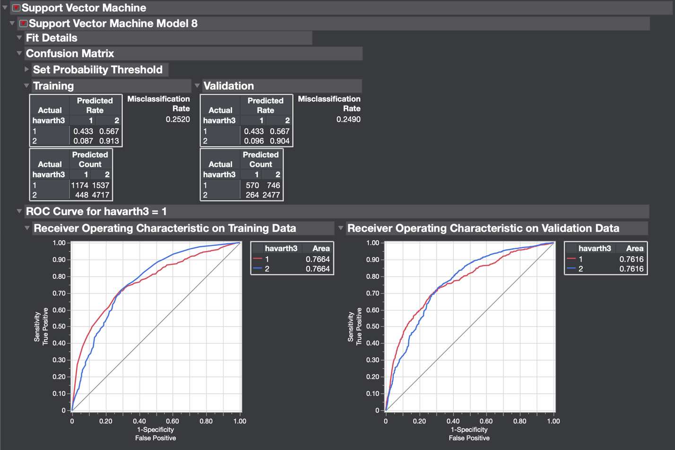

Class 1 TPR = 0.4331. Weighted average TPR for Class 1 = 0.1405. Class 2 TPR = 0.9037. Weighted average TPR for class 2 = 0.6105. Weighted combined average TPR for both classes =0.7510. FPR for class 1 = 0.0963. Weighted average FPR for class 1 = 0.0312. FPR for class 2 = 0.5669. Weighted average FPR for class 2 = 0.3830. Weighted combined average FPR for both classes =0.4142. Precision for class 1 = 0.6834. Weighted average precision for class 1 = 0.2217. Precision for class 2= 0.7685. Weighted average precision for class 2 = 0.5192. Weighted combined average precision for both classes = 0.7409. Recall for class 1 = TPR. Recall for class 2 = TPR. Weighted averages across all classes = same as TPR for Recall. F-measure of class 1 = 0.5302. Weighted average F-measure for class 1= 0.1720. F-measure for class 2= 0.8306. Weighted average F-measure for class 2 = 0.5612. Weighted combined average F-measure for both classes = 0.7332. MCC for class1 = 0.3902. Weighted average MCC for class 1 = 0.1265. MCC of class 2 = 0.3902. Weighted average MCC for class 2 = 0.2636. Weighted combined average MCC for both classes = 0.3902. Weighted average ROC area for class 1 = 0.2470. Weighted average ROC area for class 2 = 0.5145. Weighted combined average ROC area for both classes = 0.7616.

Results Obtained using Correlation Analysis Evaluator and Nominal Logistic Regression Algorithm (Best Model as illustrated above):

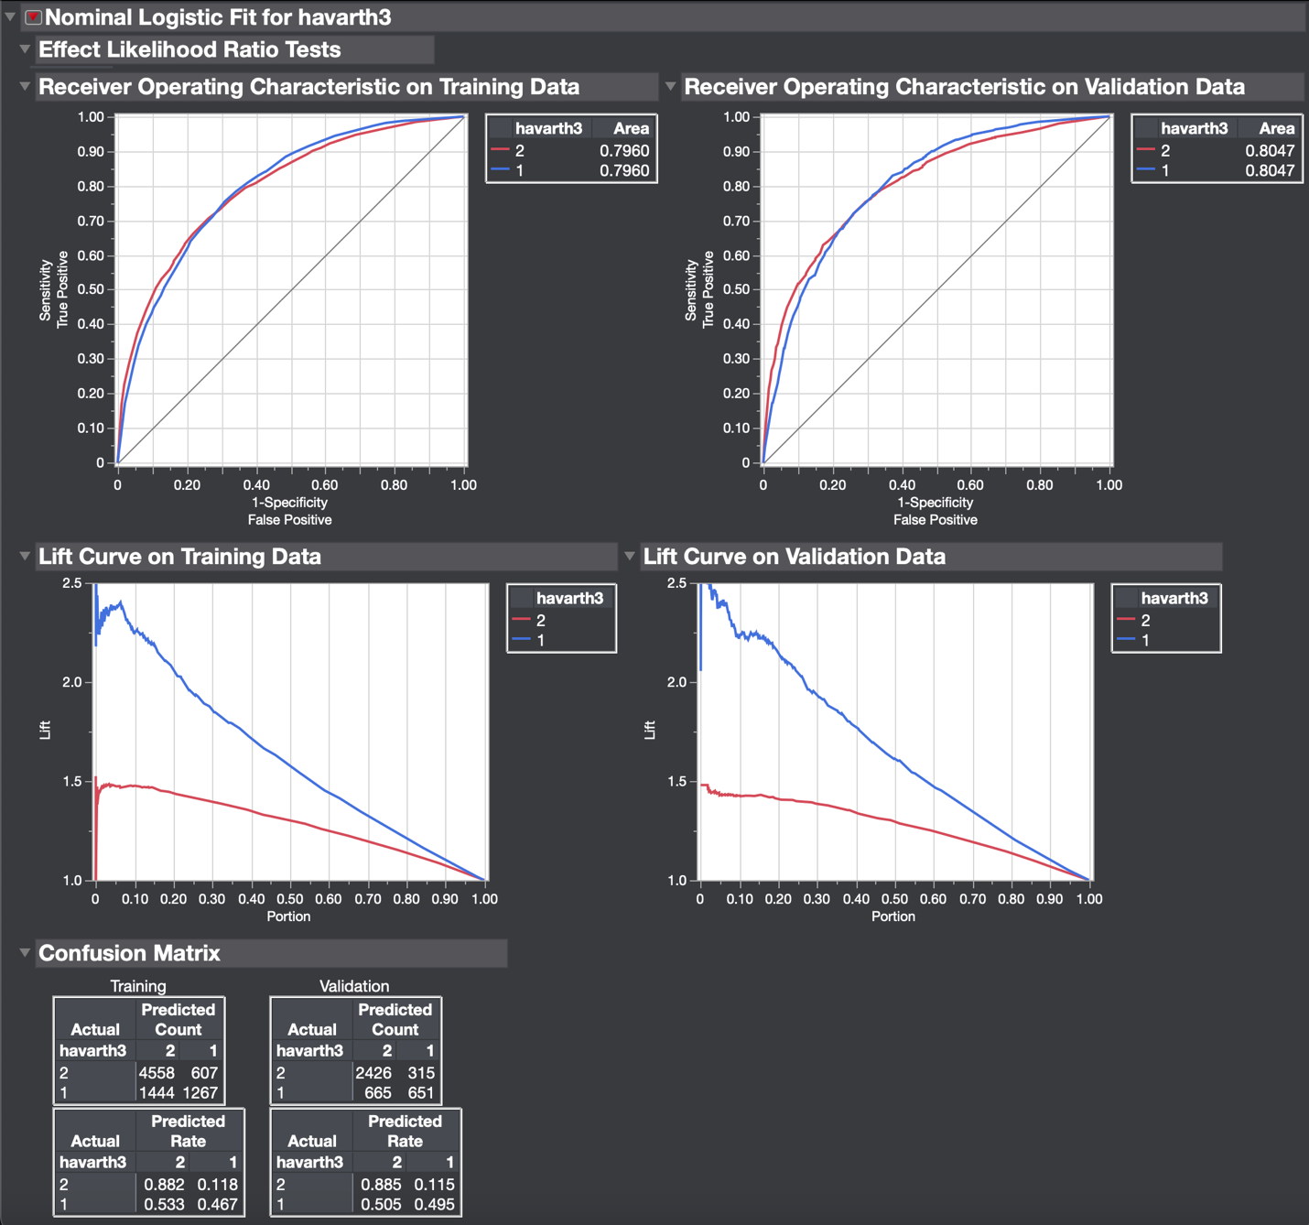

Class 1 TPR = 0.4947. Weighted average TPR for Class 1 = 0.1605. Class 2 TPR = 0.8851. Weighted average TPR for class 2 = 0.5980. Weighted combined average TPR for both classes =0.7584. FPR for class 1 = 0.1149. Weighted average FPR for class 1 = 0.0373. FPR for class 2 = 0.5053. Weighted average FPR for class 2 = 0.3414. Weighted combined average FPR for both classes =0.3787. Precision for class 1 = 0.6739. Weighted average precision for class 1 = 0.2186. Precision for class 2= 0.7848. Weighted average precision for class 2 = 0.5303. Weighted combined average precision for both classes = 0.7489. Recall for class 1 = TPR. Recall for class 2 = TPR. Weighted averages across all classes = same as TPR for Recall. F-measure of class 1 = 0.5705. Weighted average F-measure for class 1= 0.1851. F-measure for class 2= 0.8320. Weighted average F-measure for class 2 = 0.5621. Weighted combined average F-measure for both classes = 0.7472. MCC for class1 = 0.4174. Weighted average MCC for class 1 = 0.1354. MCC of class 2 = 0.4174. Weighted average MCC for class 2 = 0.2820. Weighted combined average MCC for both classes = 0.4174. Weighted average ROC area for class 1 = 0.2610. Weighted average ROC area for class 2 = 0.5437. Weighted combined average ROC area for both classes = 0.8047.

Results Obtained from using Correlation Analysis Evaluator and Decision Tree Algorithm:

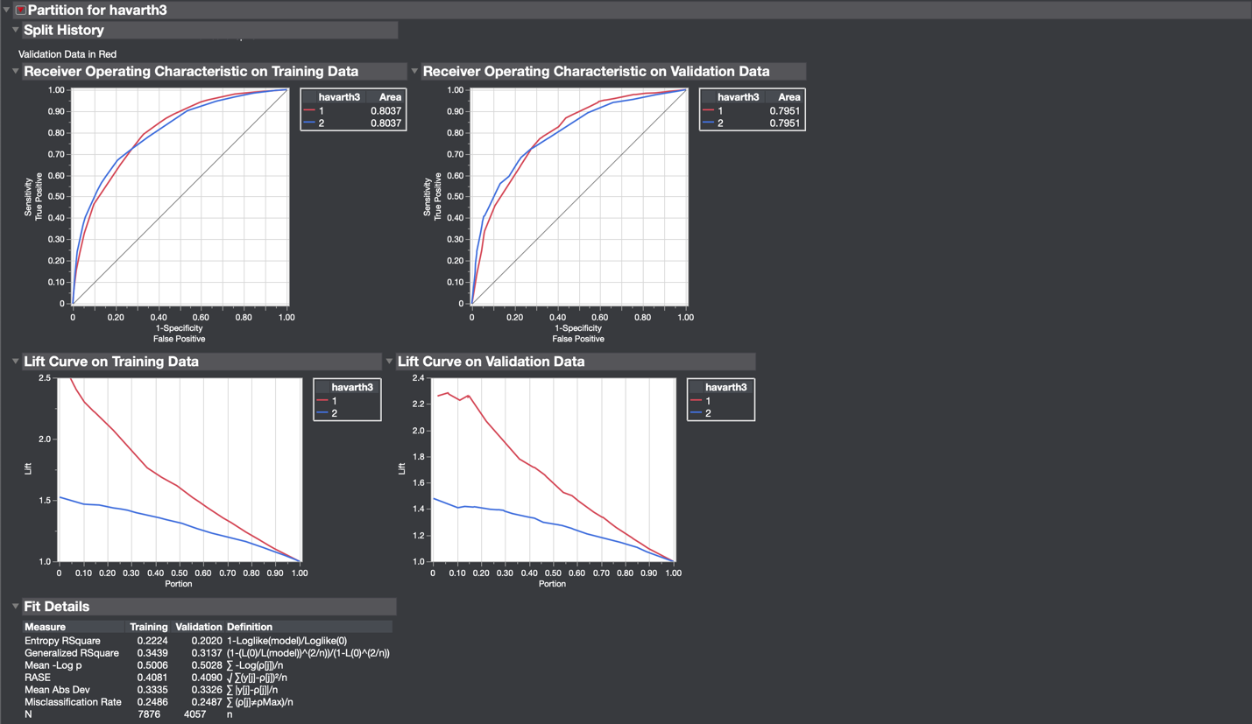

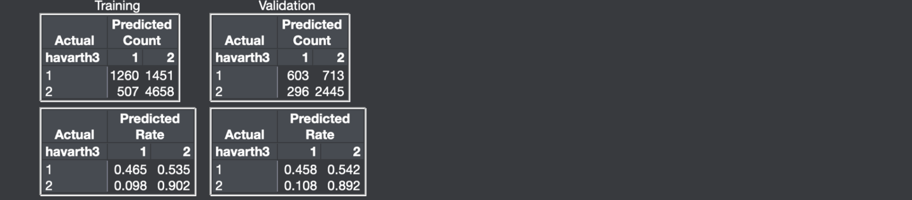

Class 1 TPR = 0.4582. Weighted average TPR for Class 1 = 0.1486. Class 2 TPR = 0.8920. Weighted average TPR for class 2 = 0.7513. Weighted combined average TPR for both classes =0.7513. FPR for class 1 = 0.1080. Weighted average FPR for class 1 = 0.0350. FPR for class 2 = 0.5418. Weighted average FPR for class 2 = 0.3660. Weighted combined average FPR for both classes =0.4010. Precision for class 1 = 0.6707. Weighted average precision for class 1 = 0.2176. Precision for class 2= 0.7742. Weighted average precision for class 2 = 0.5231. Weighted combined average precision for both classes = 0.7406. Recall for class 1 = TPR. Recall for class 2 = TPR. Weighted averages across all classes = same as TPR for Recall. F-measure of class 1 = 0.5445. Weighted average F-measure for class 1= 0.1766. F-measure for class 2= 0.8289. Weighted average F-measure for class 2 = 0.5600. Weighted combined average F-measure for both classes = 0.7367. MCC for class1 = 0.3948. Weighted average MCC for class 1 = 0.1280. MCC of class 2 = 0.3948. Weighted average MCC for class 2 = 0.2667. Weighted combined average MCC for both classes = 0.3948. Weighted average ROC area for class 1 = 0.2579. Weighted average ROC area for class 2 = 0.5372. Weighted combined average ROC area for both classes = 0.7951.

Results Obtained using Correlation Analysis Evaluator and KNN Algorithm:

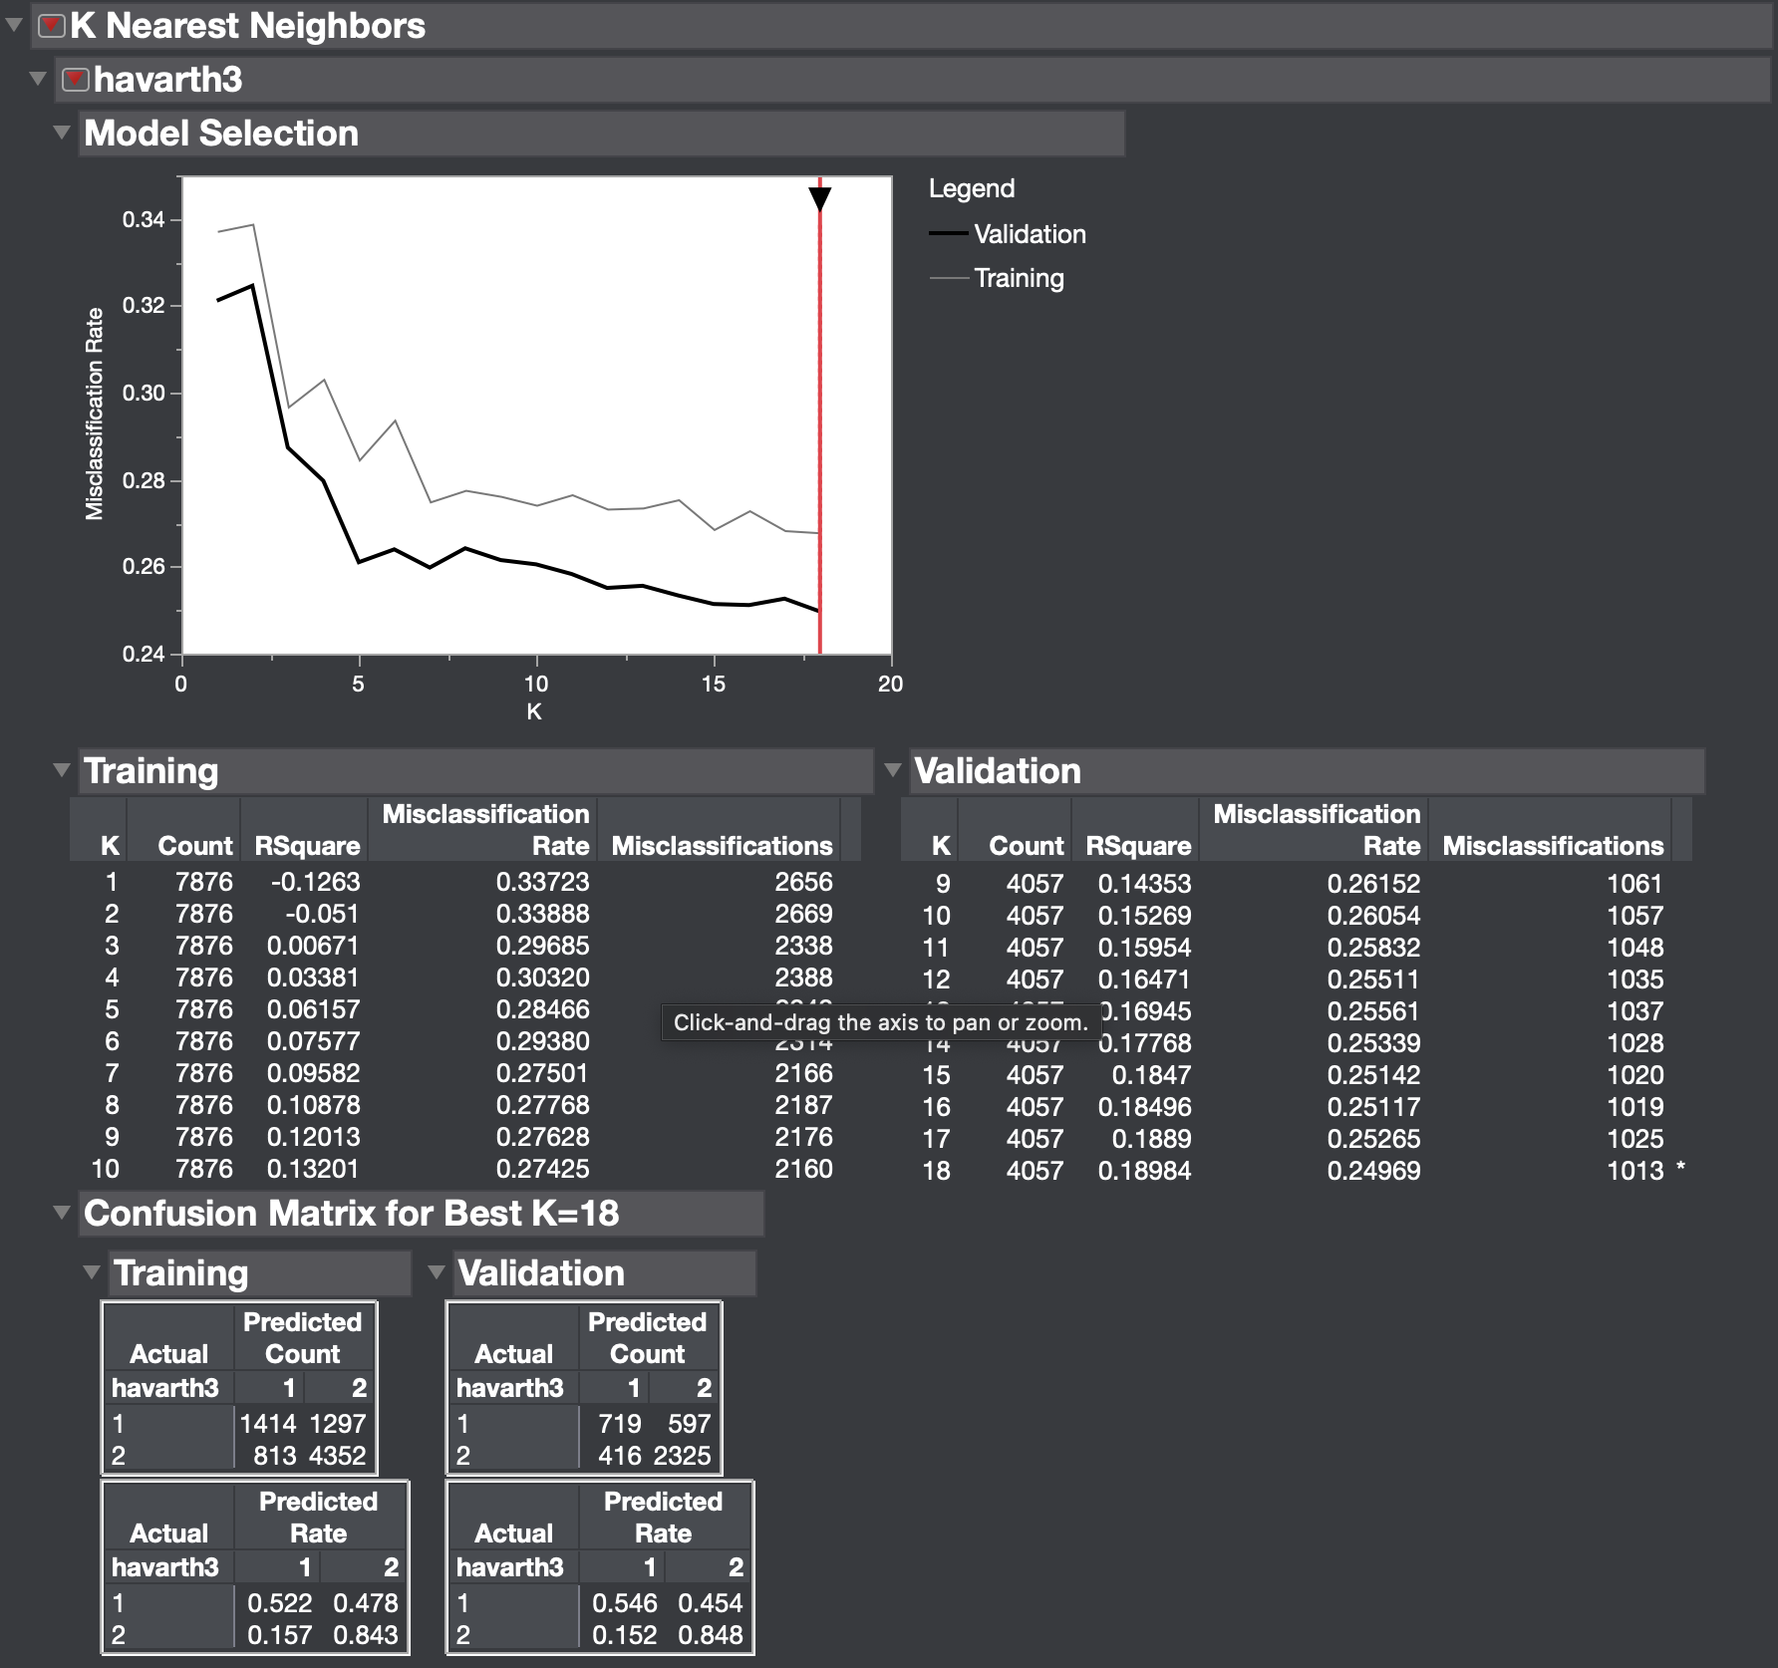

Class 1 TPR = 0.5463. Weighted average TPR for Class 1 = 0.1772. Class 2 TPR = 0.8482. Weighted average TPR for class 2 = 0.5731. Weighted combined average TPR for both classes =0.7503. FPR for class 1 = 0.1518. Weighted average FPR for class 1 = 0.0492. FPR for class 2 = 0.4536. Weighted average FPR for class 2 = 0.3065. Weighted combined average FPR for both classes =0.3557. Precision for class 1 = 0.6335. Weighted average precision for class 1 = 0.2055. Precision for class 2= 0.7957. Weighted average precision for class 2 = 0.5376. Weighted combined average precision for both classes = 0.7431. Recall for class 1 = TPR. Recall for class 2 = TPR. Weighted averages across all classes = same as TPR for Recall. F-measure of class 1 = 0.5867. Weighted average F-measure for class 1= 0.1903. F-measure for class 2= 0.8211. Weighted average F-measure for class 2 = 0.5548. Weighted combined average F-measure for both classes = 0.7451. MCC for class1 = 0.4115. Weighted average MCC for class 1 = 0.1335. MCC of class 2 = 0.4115. Weighted average MCC for class 2 = 0.2780. Weighted combined average MCC for both classes = 0.4115. K Nearest Neighbors does not include ROC curve option on JMP Pro.

Results Obtained using Correlation Analysis Evaluator and Naïve Bayes Algorithm:

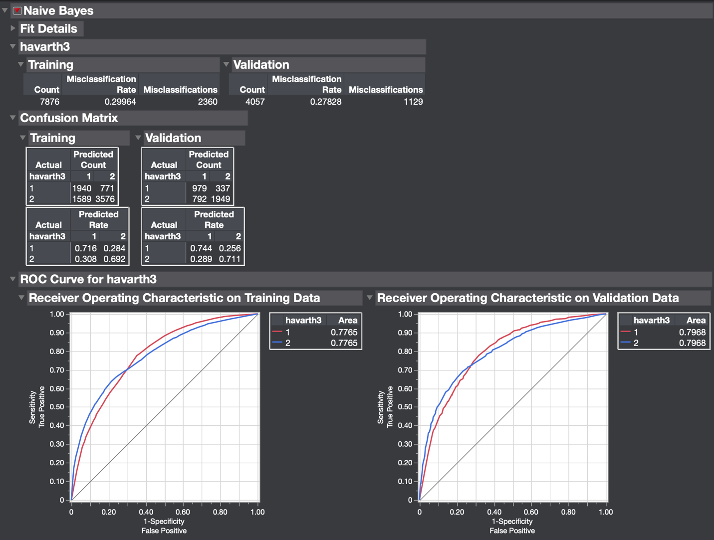

Class 1 TPR = 0.7439. Weighted average TPR for Class 1 = 0.2413. Class 2 TPR = 0.7110. Weighted average TPR for class 2 = 0.4804. Weighted combined average TPR for both classes =0.7217. FPR for class 1 = 0.2889. Weighted average FPR for class 1 = 0.0937. FPR for class 2 = 0.2561. Weighted average FPR for class 2 = 0.1730. Weighted combined average FPR for both classes =0.2667. Precision for class 1 = 0.5528. Weighted average precision for class 1 = 0.1793. Precision for class 2= 0.8526. Weighted average precision for class 2 = 0.5760. Weighted combined average precision for both classes = 0.7553. Recall for class 1 = TPR. Recall for class 2 = TPR. Weighted averages across all classes = same as TPR for Recall. F-measure of class 1 = 0.6343. Weighted average F-measure for class 1= 0.2057. F-measure for class 2= 0.8526. Weighted average F-measure for class 2 = 0.5239. Weighted combined average F-measure for both classes = 0.7296. MCC for class1 = 0.4295. Weighted average MCC for class 1 = 0.1393. MCC of class 2 = 0.4295. Weighted average MCC for class 2 = 0.2901. Weighted combined average MCC for both classes = 0.4295. Weighted average ROC area for class 1 = 0.2585. Weighted average ROC area for class 2 = 0.5383. Weighted combined average ROC area for both classes = 0.7968.

Results Obtained using Correlation Analysis Evaluator and SVM Algorithm:

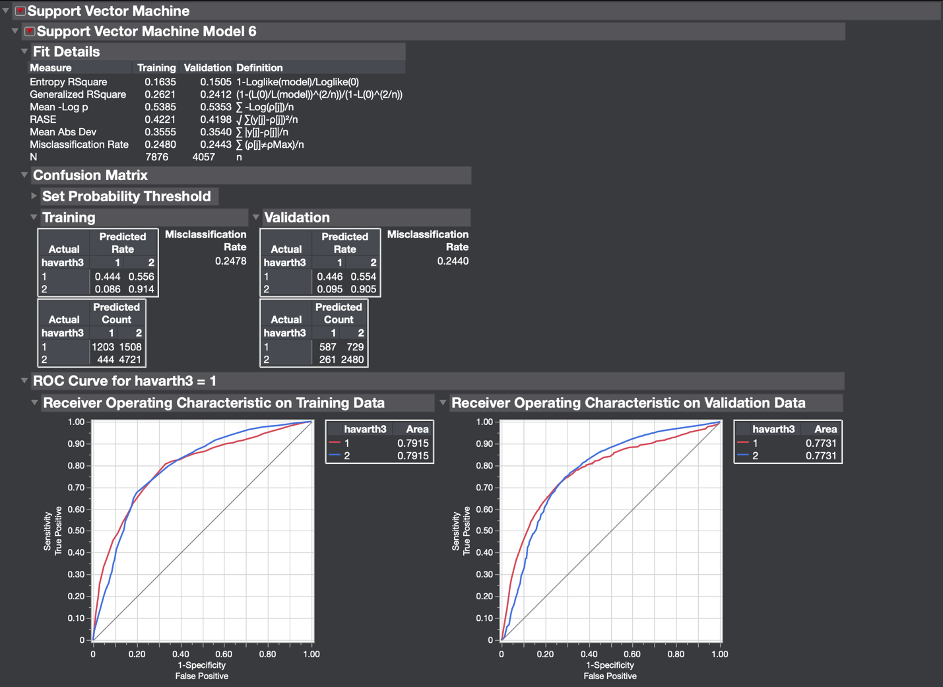

Class 1 TPR = 0.4460. Weighted average TPR for Class 1 = 0.1447. Class 2 TPR = 0.9048. Weighted average TPR for class 2 = 0.6113. Weighted combined average TPR for both classes =0.7560. FPR for class 1 = 0.0952. Weighted average FPR for class 1 = 0.0309. FPR for class 2 = 0.5539. Weighted average FPR for class 2 = 0.3743. Weighted combined average FPR for both classes =0.4051. Precision for class 1 = 0.6922. Weighted average precision for class 1 = 0.2245. Precision for class 2= 0.7728. Weighted average precision for class 2 = 0.5221. Weighted combined average precision for both classes = 0.7467. Recall for class 1 = TPR. Recall for class 2 = TPR. Weighted averages across all classes = same as TPR for Recall. F-measure of class 1 = 0.5425. Weighted average F-measure for class 1= 0.1760. F-measure for class 2= 0.8336. Weighted average F-measure for class 2 = 0.5632. Weighted combined average F-measure for both classes = 0.7392. MCC for class1 = 0.4039. Weighted average MCC for class 1 = 0.1310. MCC of class 2 = 0.4039. Weighted average MCC for class 2 = 0.2729. Weighted combined average MCC for both classes = 0.4039. Weighted average ROC area for class 1 = 0.2508. Weighted average ROC area for class 2 = 0.5223. Weighted combined average ROC area for both classes = 0.7731.

Results Obtained from using Cfs Subset Evaluator and Nominal Logistic Regression Algorithm:

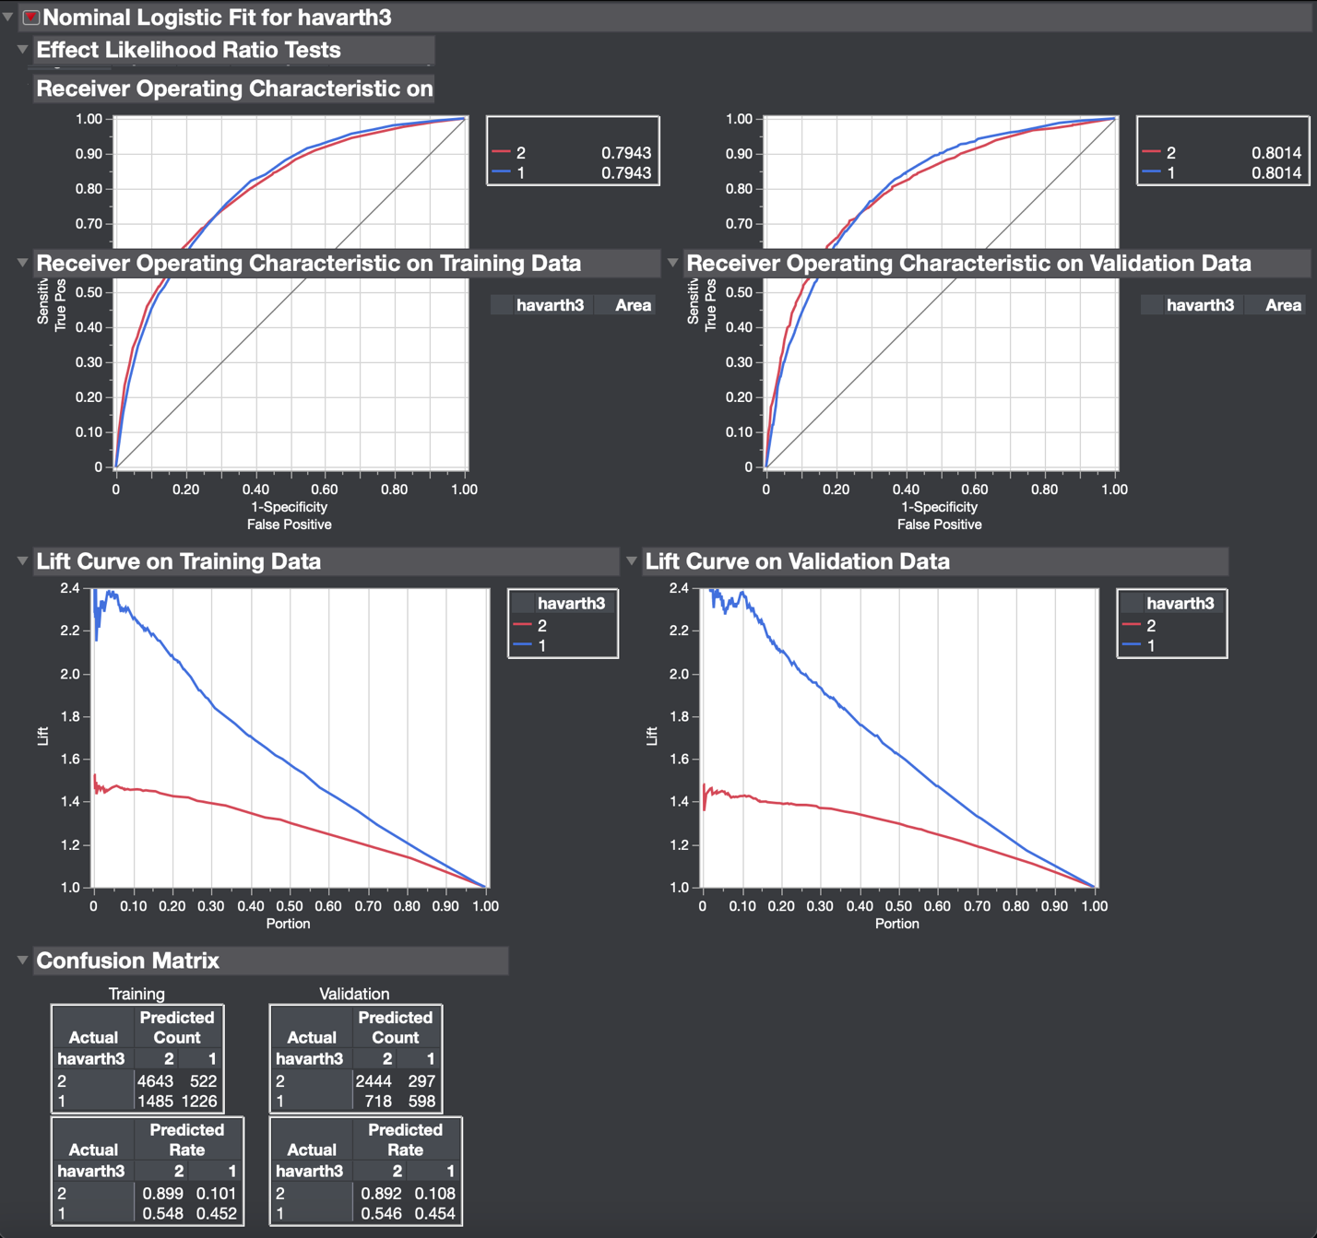

Class 1 TPR = 0.4544. Weighted average TPR for Class 1 = 0.1474. Class 2 TPR = 0.8916. Weighted average TPR for class 2 = 0.6024. Weighted combined average TPR for both classes =0.7498. FPR for class 1 = 0.1083. Weighted average FPR for class 1 = 0.0351. FPR for class 2 = 0.5456. Weighted average FPR for class 2 = 0.3686. Weighted combined average FPR for both classes =0.4038. Precision for class 1 = 0.6681. Weighted average precision for class 1 = 0.2167. Precision for class 2= 0.7729. Weighted average precision for class 2 = 0.5222. Weighted combined average precision for both classes = 0.7389. Recall for class 1 = TPR. Recall for class 2 = TPR. Weighted averages across all classes = same as TPR for Recall. F-measure of class 1 = 0.5409. Weighted average F-measure for class 1= 0.1755. F-measure for class 2= 0.8280. Weighted average F-measure for class 2 = 0.5594. Weighted combined average F-measure for both classes = 0.7349. MCC for class1 = 0.3907. Weighted average MCC for class 1 = 0.1267. MCC of class 2 = 0.4295. Weighted average MCC for class 2 = 0.2639. Weighted combined average MCC for both classes = 0.3907. Weighted average ROC area for class 1 = 0.2600. Weighted average ROC area for class 2 = 0.5414. Weighted combined average ROC area for both classes = 0.8014.

Results Obtained from using Cfs Subset Evaluator and Decision Tree Algorithm:

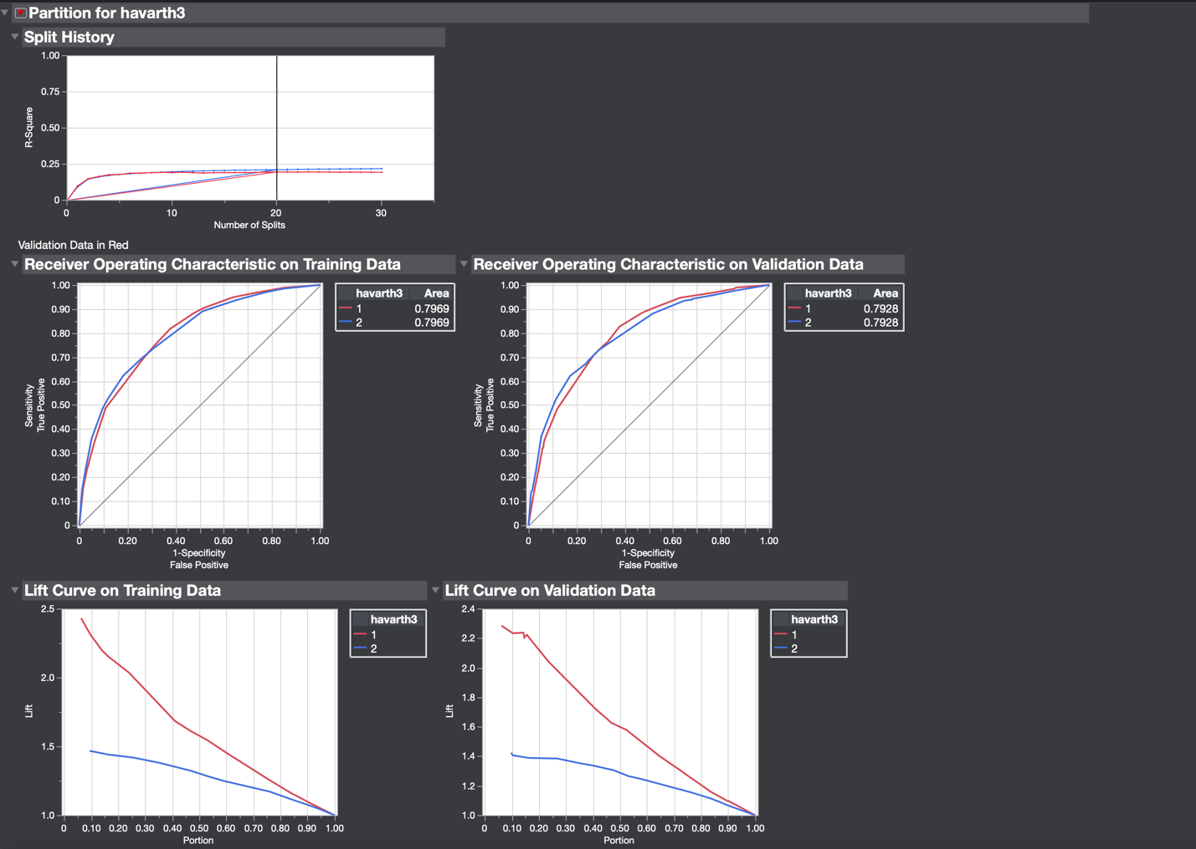

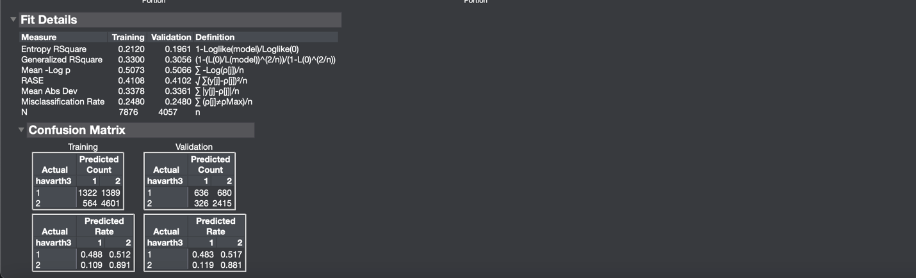

Class 1 TPR = 0.4833. Weighted average TPR for Class 1 = 0.1568. Class 2 TPR = 0.8811. Weighted average TPR for class 2 = 0.5953. Weighted combined average TPR for both classes =0.7520. FPR for class 1 = 0.1189. Weighted average FPR for class 1 = 0.0386. FPR for class 2 = 0.5167. Weighted average FPR for class 2 = 0.3491. Weighted combined average FPR for both classes =0.3877. Precision for class 1 = 0.6611. Weighted average precision for class 1 = 0.2144. Precision for class 2= 0.7803. Weighted average precision for class 2 = 0.5272. Weighted combined average precision for both classes = 0.7416. Recall for class 1 = TPR. Recall for class 2 = TPR. Weighted averages across all classes = same as TPR for Recall. F-measure of class 1 = 0.5584. Weighted average F-measure for class 1= 0.1811. F-measure for class 2= 0.8276. Weighted average F-measure for class 2 = 0.5591. Weighted combined average F-measure for both classes = 0.7403. MCC for class1 = 0.4010. Weighted average MCC for class 1 = 0.1301. MCC of class 2 = 0.4010. Weighted average MCC for class 2 = 0.2709. Weighted combined average MCC for both classes = 0.4010. Weighted average ROC area for class 1 = 0.2572. Weighted average ROC area for class 2 = 0.5356. Weighted combined average ROC area for both classes = 0.7928.

Results Obtained from using Cfs Subset Evaluator and K Nearest Neighbors Algorithm:

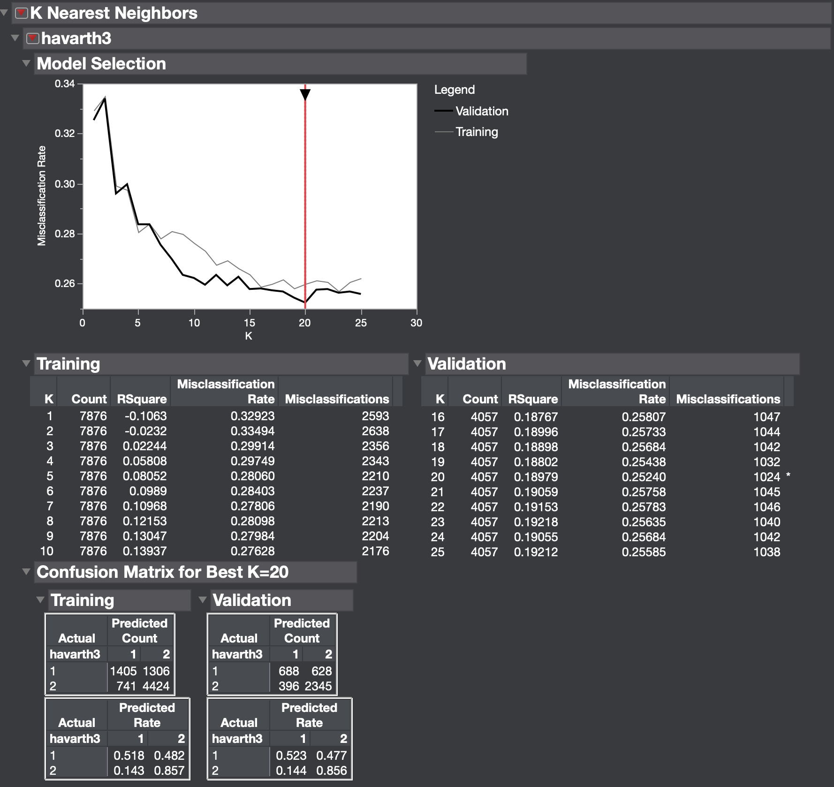

Class 1 TPR = 0.5228. Weighted average TPR for Class 1 = 0.1696. Class 2 TPR = 0.8555. Weighted average TPR for class 2 = 0.5780. Weighted combined average TPR for both classes =0.7476. FPR for class 1 = 0.1445. Weighted average FPR for class 1 = 0.0469. FPR for class 2 = 0.4772. Weighted average FPR for class 2 = 0.3224. Weighted combined average FPR for both classes =0.3693. Precision for class 1 = 0.6347. Weighted average precision for class 1 = 0.2059. Precision for class 2= 0.7888. Weighted average precision for class 2 = 0.5329. Weighted combined average precision for both classes = 0.7388. Recall for class 1 = TPR. Recall for class 2 = TPR. Weighted averages across all classes = same as TPR for Recall. F-measure of class 1 = 0.5733. Weighted average F-measure for class 1= 0.1860. F-measure for class 2= 0.8208. Weighted average F-measure for class 2 = 0.5545. Weighted combined average F-measure for both classes = 0.7405. MCC for class1 = 0.4002. Weighted average MCC for class 1 = 0.1298. MCC of class 2 = 0.4002. Weighted average MCC for class 2 = 0.2704. Weighted combined average MCC for both classes = 0.4002. K Nearest Neighbors does not include ROC curve option on JMP Pro.

Results Obtained using Cfs Subset Evaluator and Naïve Bayes Algorithm:

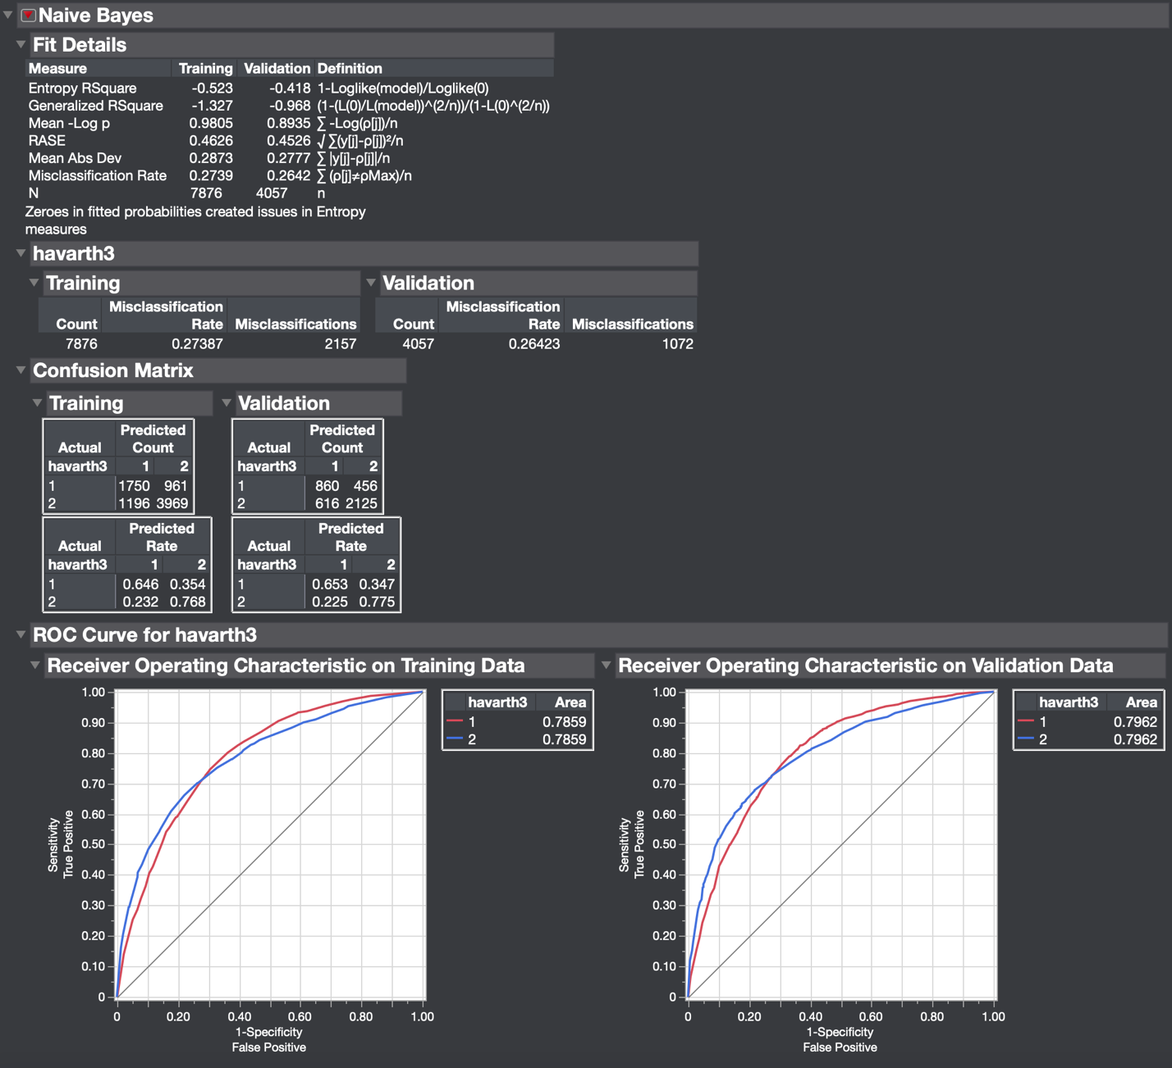

Class 1 TPR = 0.6535. Weighted average TPR for Class 1 = 0.2120. Class 2 TPR = 0.7986. Weighted average TPR for class 2 = 0.5238. Weighted combined average TPR for both classes =0.7358. FPR for class 1 = 0.2247. Weighted average FPR for class 1 = 0.0729. FPR for class 2 = 0.3465. Weighted average FPR for class 2 = 0.2341. Weighted combined average FPR for both classes = 0.3070. Precision for class 1 = 0.5826. Weighted average precision for class 1 = 0.1890. Precision for class 2= 0.8233. Weighted average precision for class 2 = 0.5562. Weighted combined average precision for both classes = 0.7452. Recall for class 1 = TPR. Recall for class 2 = TPR. Weighted averages across all classes = same as TPR for Recall. F-measure of class 1 = 0.6160. Weighted average F-measure for class 1= 0.1998. F-measure for class 2= 0.7986. Weighted average F-measure for class 2 = 0.5395. Weighted combined average F-measure for both classes = 0.7394. MCC for class1 = 0.4172. Weighted average MCC for class 1 = 0.1353. MCC of class 2 = 0.4172. Weighted average MCC for class 2 = 0.2819. Weighted combined average MCC for both classes = 0.4172. Weighted average ROC area for class 1 = 0.2583. Weighted average ROC area for class 2 = 0.5379. Weighted combined average ROC area for both classes = 0.7962.

Results Obtained using Cfs Subset Evaluator and Naïve Bayes Algorithm:

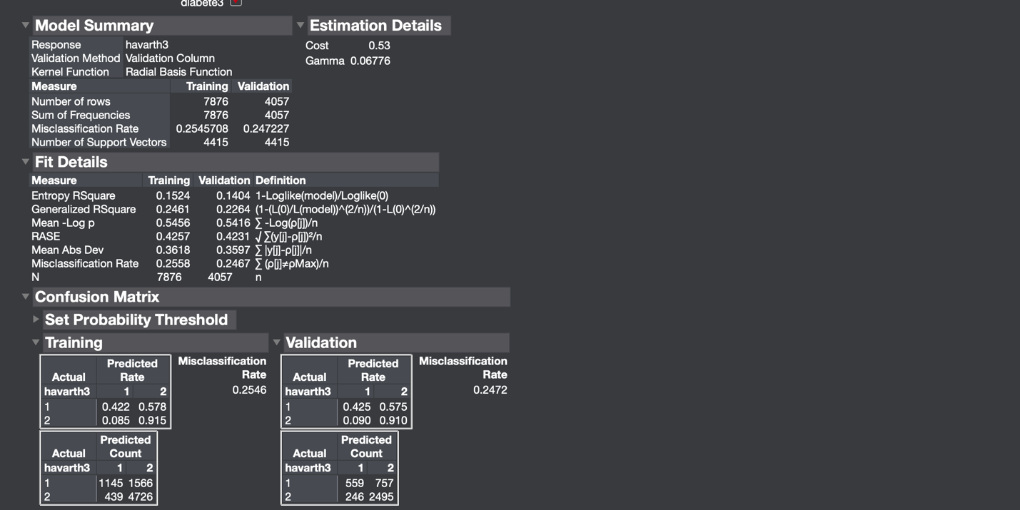

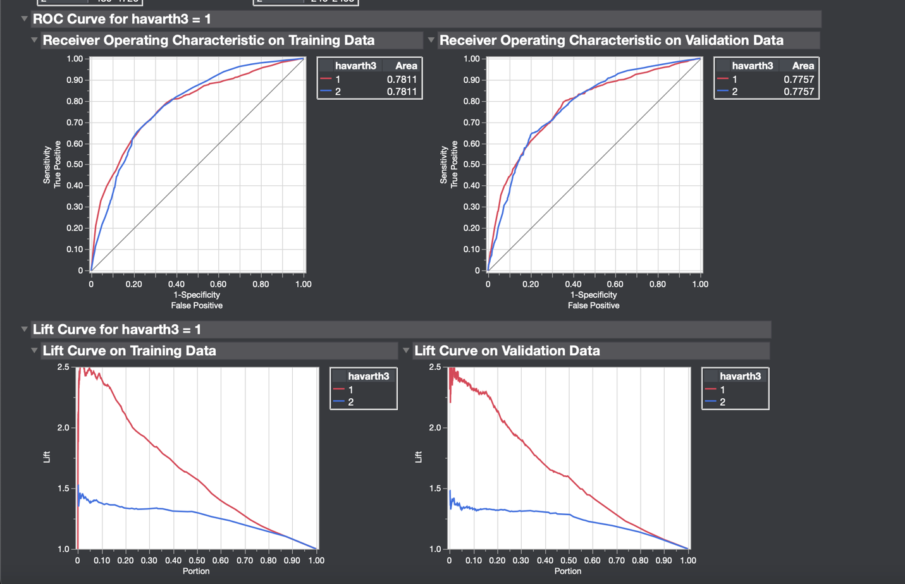

Class 1 TPR = 0.4248. Weighted average TPR for Class 1 = 0.1378. Class 2 TPR = 0.9102. Weighted average TPR for class 2 = 0.6150. Weighted combined average TPR for both classes =0.7528. FPR for class 1 = 0.0897. Weighted average FPR for class 1 = 0.0291. FPR for class 2 = 0.5752. Weighted average FPR for class 2 = 0.3886. Weighted combined average FPR for both classes =0.4177. Precision for class 1 = 0.6944. Weighted average precision for class 1 = 0.2252. Precision for class 2= 0.7672. Weighted average precision for class 2 = 0.55183. Weighted combined average precision for both classes = 0.7436. Recall for class 1 = TPR. Recall for class 2 = TPR. Weighted averages across all classes = same as TPR for Recall. F-measure of class 1 = 0.5271. Weighted average F-measure for class 1= 0.1710. F-measure for class 2= 0.8326. Weighted average F-measure for class 2 = 0.5625. Weighted combined average F-measure for both classes = 0.7335. MCC for class1 = 0.3933. Weighted average MCC for class 1 = 0.1276. MCC of class 2 = 0.3933. Weighted average MCC for class 2 = 0.2657. Weighted combined average MCC for both classes = 0.3933. Weighted average ROC area for class 1 = 0.2516. Weighted average ROC area for class 2 = 0.5241. Weighted combined average ROC area for both classes = 0.7757.

Results Obtained Using Gain Ratio Evaluator and Nominal Logistic Regression Algorithm:

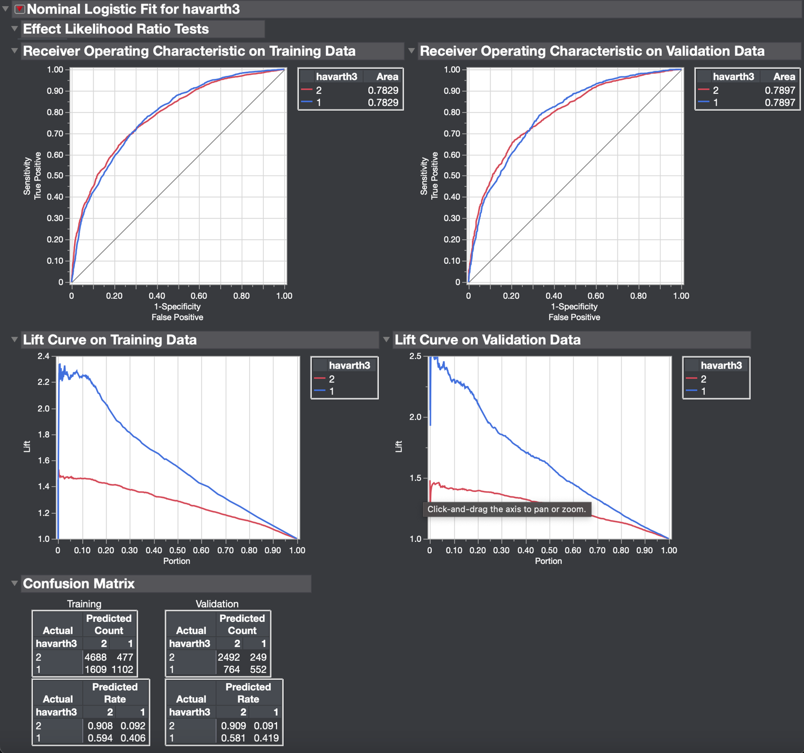

Class 1 TPR = 0.4194. Weighted average TPR for Class 1 = 0.1361. Class 2 TPR = 0.9091. Weighted average TPR for class 2 = 0.6142. Weighted combined average TPR for both classes =0.7503. FPR for class 1 = 0.0908. Weighted average FPR for class 1 = 0.0295. FPR for class 2 = 0.5805. Weighted average FPR for class 2 = 0.3922. Weighted combined average FPR for both classes =0.4217. Precision for class 1 = 0.6891. Weighted average precision for class 1 = 0.2235. Precision for class 2= 0.7653. Weighted average precision for class 2 = 0.5171. Weighted combined average precision for both classes = 0.7406. Recall for class 1 = TPR. Recall for class 2 = TPR. Weighted averages across all classes = same as TPR for Recall. F-measure of class 1 = 0.5215. Weighted average F-measure for class 1= 0.1692. F-measure for class 2= 0.8311. Weighted average F-measure for class 2 = 0.5615. Weighted combined average F-measure for both classes = 0.7306. MCC for class1 = 0.3865. Weighted average MCC for class 1 = 0.1253. MCC of class 2 = 0.3865. Weighted average MCC for class 2 = 0.2611. Weighted combined average MCC for both classes = 0.3865. Weighted average ROC area for class 1 = 0.2562. Weighted average ROC area for class 2 = 0.5335. Weighted combined average ROC area for both classes = 0.7897.

Results Obtained using Gain Ratio Evaluator and Decision Tree Algorithm:

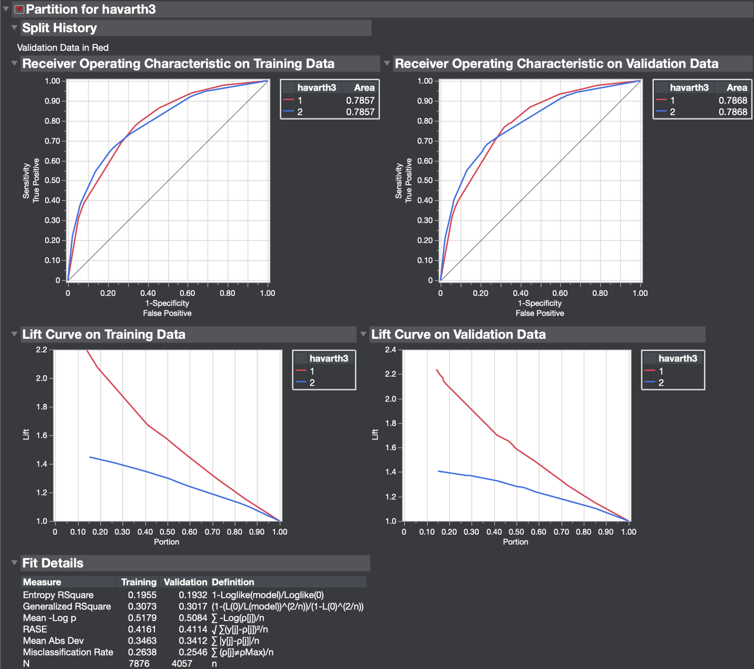

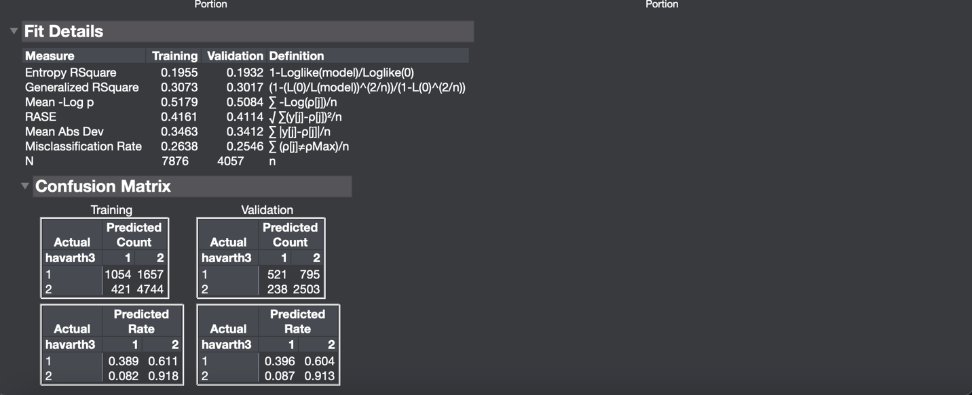

Class 1 TPR = 0.3959. Weighted average TPR for Class 1 = 0.1284. Class 2 TPR = 0.9132. Weighted average TPR for class 2 = 0.6169. Weighted combined average TPR for both classes =0.7454. FPR for class 1 = 0.0870. Weighted average FPR for class 1 = 0.0282. FPR for class 2 = 0.6041. Weighted average FPR for class 2 = 0.4081. Weighted combined average FPR for both classes =0.4363. Precision for class 1 = 0.6864. Weighted average precision for class 1 = 0.2227. Precision for class 2= 0.7589. Weighted average precision for class 2 = 0.5128. Weighted combined average precision for both classes = 0.7354. Recall for class 1 = TPR. Recall for class 2 = TPR. Weighted averages across all classes = same as TPR for Recall. F-measure of class 1 = 0.5022. Weighted average F-measure for class 1= 0.1629. F-measure for class 2= 0.8289. Weighted average F-measure for class 2 = 0.5600. Weighted combined average F-measure for both classes = 0.7229. MCC for class1 = 0.3710. Weighted average MCC for class 1 = 0.1203. MCC of class 2 = 0.3710. Weighted average MCC for class 2 = 0.2507. Weighted combined average MCC for both classes = 0.3710. Weighted average ROC area for class 1 = 0.2552. Weighted average ROC area for class 2 = 0.5316. Weighted combined average ROC area for both classes = 0.7868.

Results Obtained using Gain Ratio Evaluator and K Nearest Neighbors Algorithm:

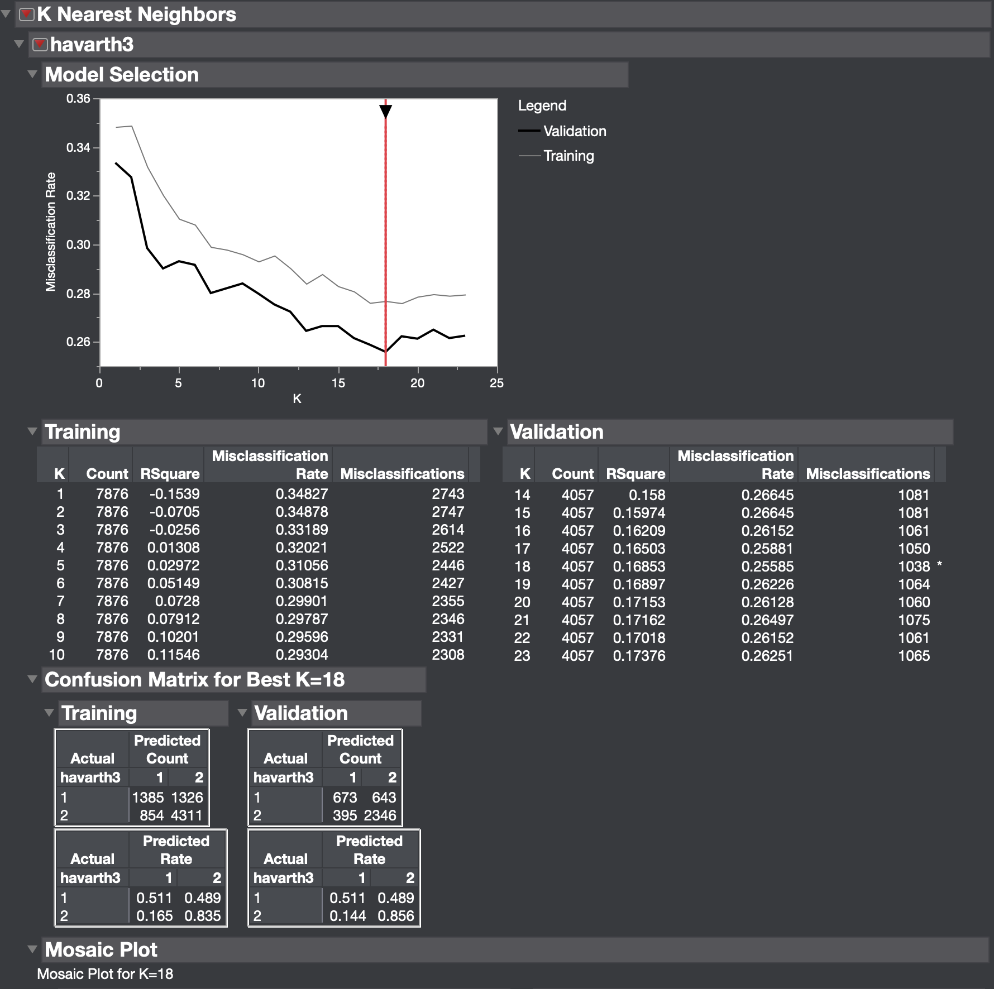

Class 1 TPR = 0.5114. Weighted average TPR for Class 1 = 0.1659. Class 2 TPR = 0.8559. Weighted average TPR for class 2 = 0.5782. Weighted combined average TPR for both classes =0.7441. FPR for class 1 = 0.1441. Weighted average FPR for class 1 = 0.0467. FPR for class 2 = 0.4886. Weighted average FPR for class 2 = 0.3301. Weighted combined average FPR for both classes =0.3768. Precision for class 1 = 0.6301. Weighted average precision for class 1 = 0.2044. Precision for class 2= 0.7849. Weighted average precision for class 2 = 0.5303. Weighted combined average precision for both classes = 0.7347. Recall for class 1 = TPR. Recall for class 2 = TPR. Weighted averages across all classes = same as TPR for Recall. F-measure of class 1 = 0.5646. Weighted average F-measure for class 1= 0.1831. F-measure for class 2= 0.8188. Weighted average F-measure for class 2 = 0.5532. Weighted combined average F-measure for both classes = 0.7364. MCC for class1 = 0.3904. Weighted average MCC for class 1 = 0.1266. MCC of class 2 = 0.3904. Weighted average MCC for class 2 = 0.2638. Weighted combined average MCC for both classes = 0.3904. K Nearest Neighbors does not include ROC curve option on JMP Pro.

Results Obtained using Gain Ratio Evaluator and Naïve Bayes Algorithm:

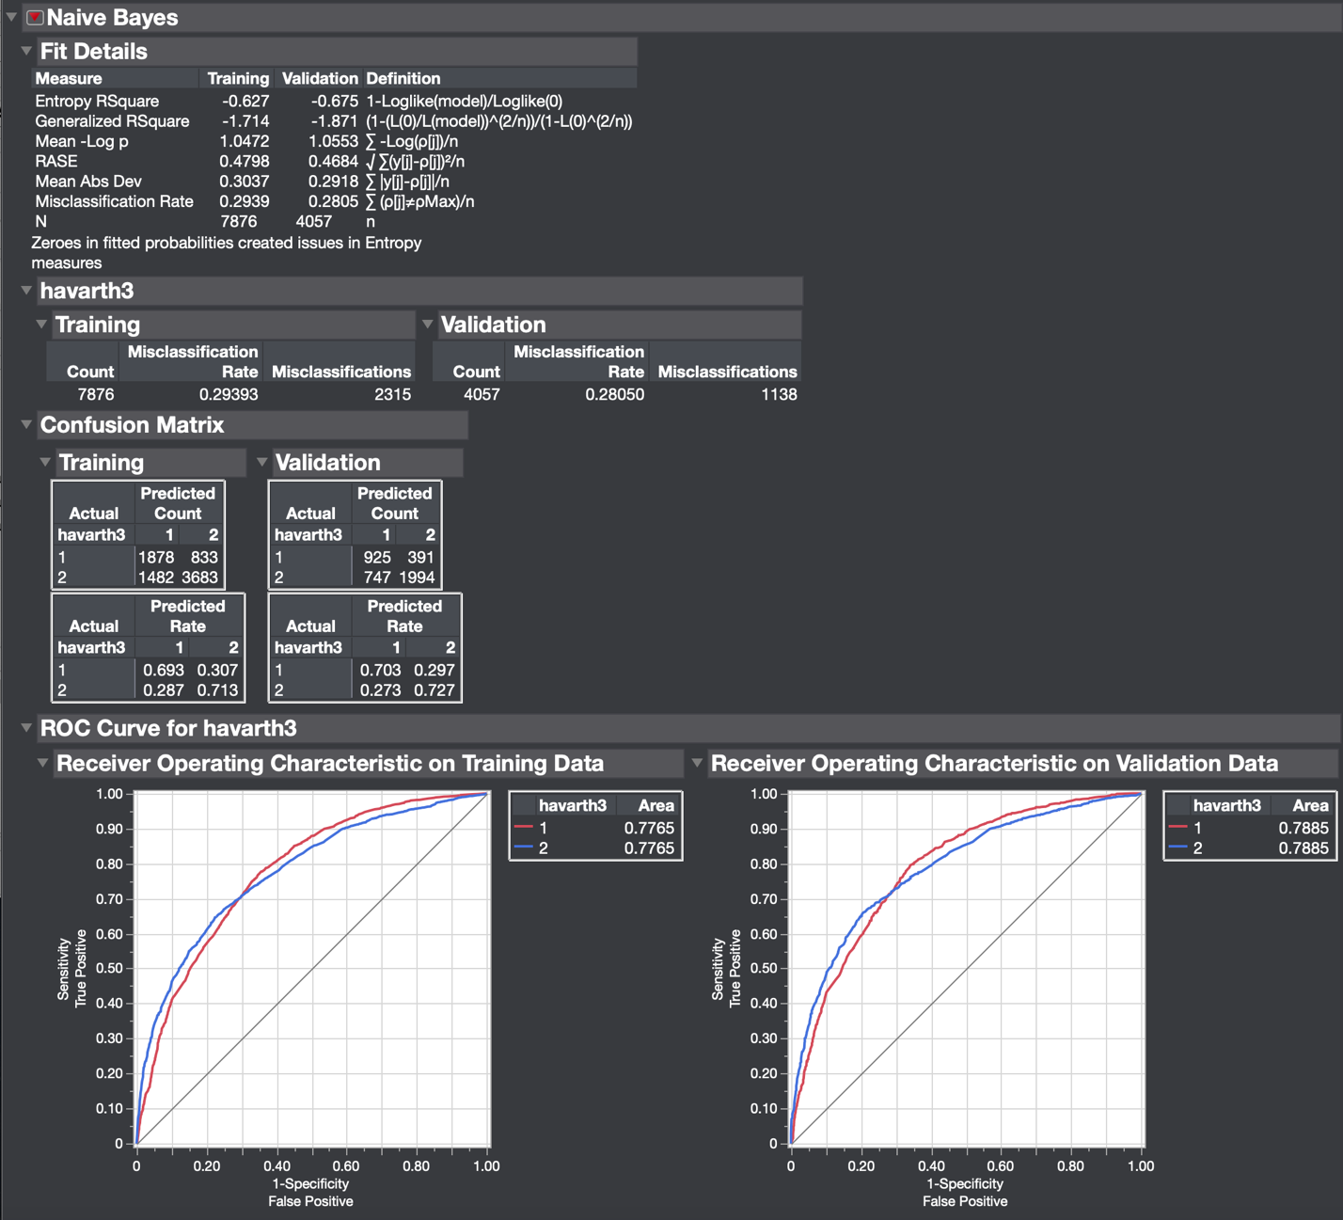

Class 1 TPR = 0.7029. Weighted average TPR for Class 1 = 0.2280. Class 2 TPR = 0.7274. Weighted average TPR for class 2 = 0.4915. Weighted combined average TPR for both classes =0.7195. FPR for class 1 = 0.2725. Weighted average FPR for class 1 = 0.0884. FPR for class 2 = 0.2971. Weighted average FPR for class 2 = 0.2007. Weighted combined average FPR for both classes =0.2891. Precision for class 1 = 0.5532. Weighted average precision for class 1 = 0.1794. Precision for class 2= 0.8360. Weighted average precision for class 2 = 0.5648. Weighted combined average precision for both classes = 0.7443. Recall for class 1 = TPR. Recall for class 2 = TPR. Weighted averages across all classes = same as TPR for Recall. F-measure of class 1 = 0.6191. Weighted average F-measure for class 1= 0.2008. F-measure for class 2= 0.7780. Weighted average F-measure for class 2 = 0.5256. Weighted combined average F-measure for both classes = 0.7265. MCC for class1 = 0.4093. Weighted average MCC for class 1 = 0.1328. MCC of class 2 = 0.4093. Weighted average MCC for class 2 = 0.2765. Weighted combined average MCC for both classes = 0.4093. Weighted average ROC area for class 1 = 0.2558. Weighted average ROC area for class 2 = 0.5327. Weighted combined average ROC area for both classes = 0.7885.

Results Obtained using Gain Ratio Evaluator and SVM Algorithm:

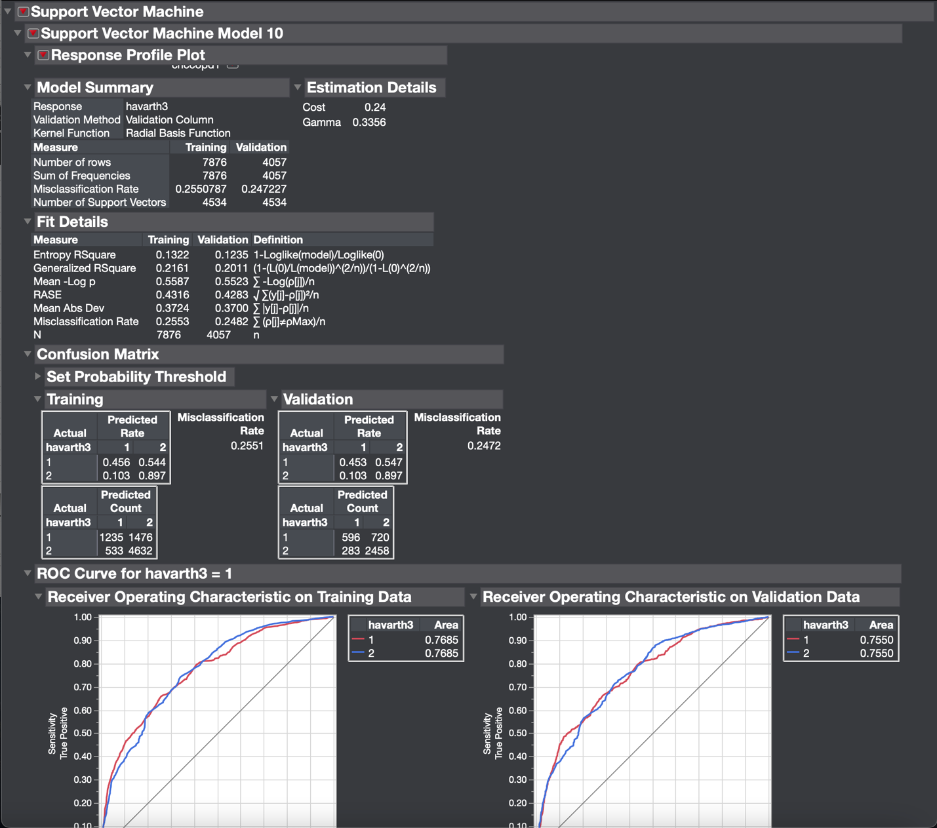

Class 1 TPR = 0.4912. Weighted average TPR for Class 1 = 0.1593. Class 2 TPR = 0.8967. Weighted average TPR for class 2 = 0.6059. Weighted combined average TPR for both classes =0.7652. FPR for class 1 = 0.1032. Weighted average FPR for class 1 = 0.0335. FPR for class 2 = 0.3696. Weighted average FPR for class 2 = 0.4031. Weighted combined average FPR for both classes =0.4031. Precision for class 1 = 0.7106. Weighted average precision for class 1 = 0.2305. Precision for class 2= 0.7734. Weighted average precision for class 2 = 0.5225. Weighted combined average precision for both classes = 0.7531. Recall for class 1 = TPR. Recall for class 2 = TPR. Weighted averages across all classes = same as TPR for Recall. F-measure of class 1 = 0.5809. Weighted average F-measure for class 1= 0.1884. F-measure for class 2= 0.8305. Weighted average F-measure for class 2 = 0.5611. Weighted combined average F-measure for both classes = 0.7495. MCC for class1 = 0.4333. Weighted average MCC for class 1 = 0.1406. MCC of class 2 = 0.4333. Weighted average MCC for class 2 = 0.2928. Weighted combined average MCC for both classes = 0.4333. Weighted average ROC area for class 1 = 0.2449. Weighted average ROC area for class 2 = 0.5100. Weighted combined average ROC area for both classes = 0.7550.

Results Obtained using ReliefF Attribute Evaluator and Nominal Logistic Regression Algorithm:

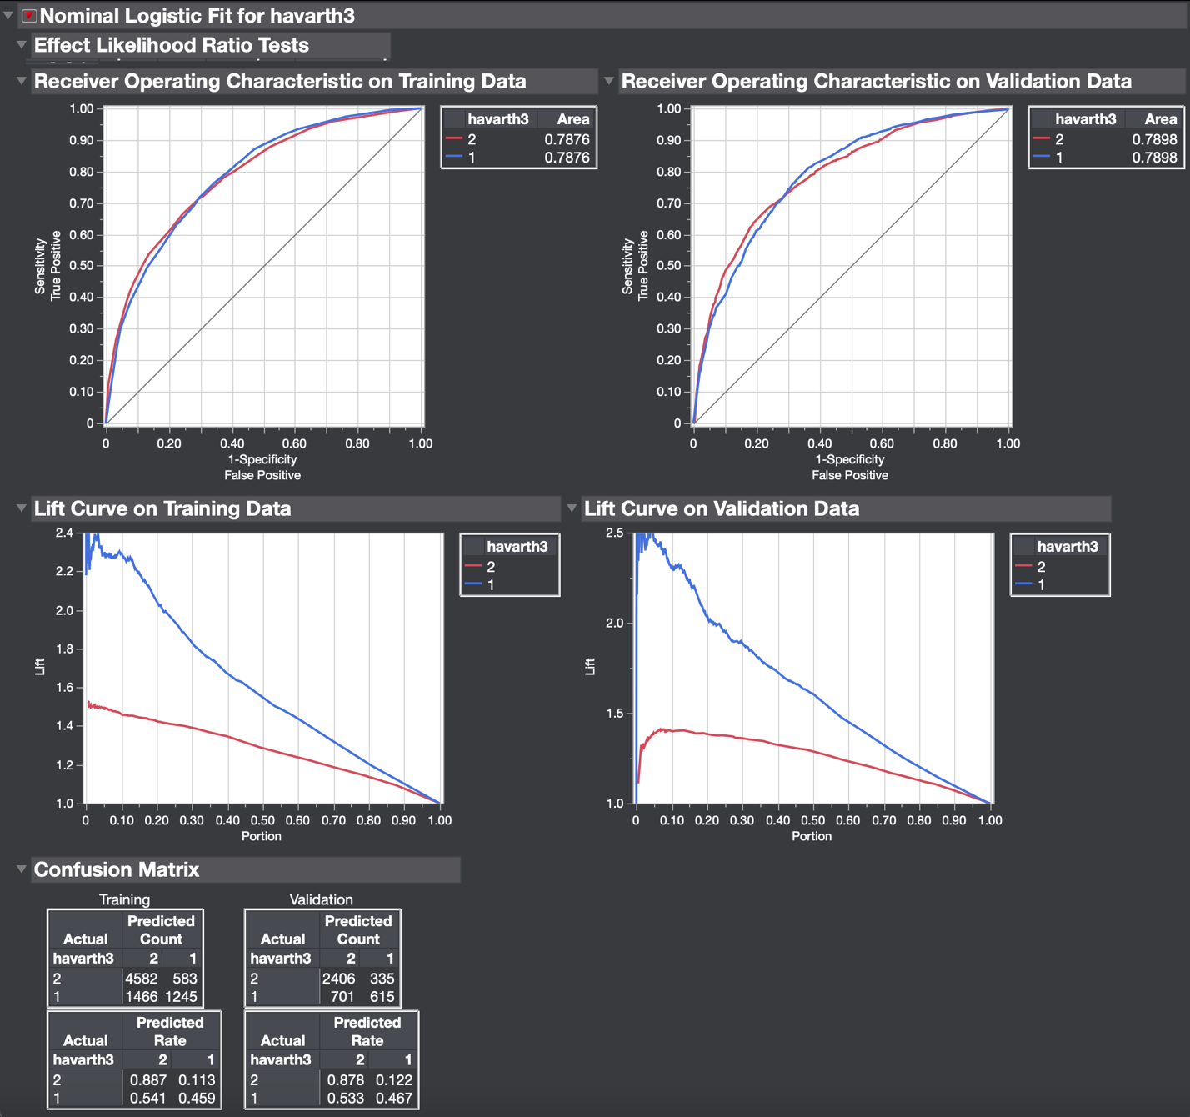

Class 1 TPR = 0.4673. Weighted average TPR for Class 1 = 0.1516. Class 2 TPR = 0.8773. Weighted average TPR for class 2 = 0.5930. Weighted combined average TPR for both classes =0.7446. FPR for class 1 = 0.1223. Weighted average FPR for class 1 = 0.0396. FPR for class 2 = 0.5327. Weighted average FPR for class 2 = 0.3599. Weighted combined average FPR for both classes = 0.3995. Precision for class 1 = 0.6474. Weighted average precision for class 1 = 0.2100. Precision for class 2= 0.7743. Weighted average precision for class 2 = 0.5231. Weighted combined average precision for both classes = 0.7320. Recall for class 1 = TPR. Recall for class 2 = TPR. Weighted averages across all classes = same as TPR for Recall. F-measure of class 1 = 0.5428. Weighted average F-measure for class 1= 0.1761. F-measure for class 2= 0.8228. Weighted average F-measure for class 2 = 0.5589. Weighted combined average F-measure for both classes = 0.7320. MCC for class1 = 0.3814. Weighted average MCC for class 1 = 0.1237. MCC of class 2 = 0.3814. Weighted average MCC for class 2 = 0.2577. Weighted combined average MCC for both classes = 0.3814. Weighted average ROC area for class 1 = 0.2562. Weighted average ROC area for class 2 = 0.5336. Weighted combined average ROC area for both classes = 0.7898.

Results Obtained using ReliefF Attribute Evaluator and Decision Tree Algorithm:

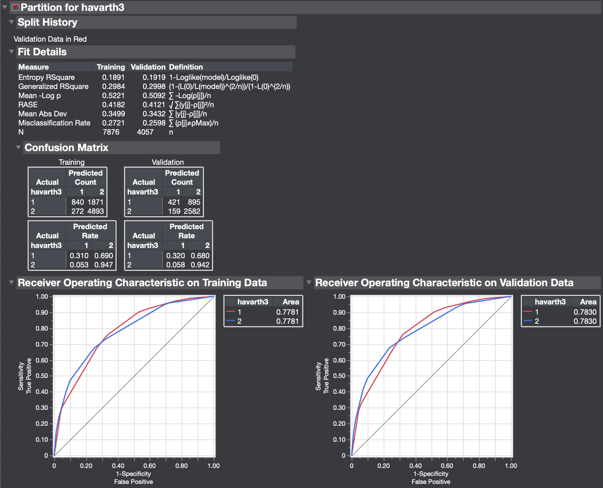

Class 1 TPR = 0.3199. Weighted average TPR for Class 1 = 0.1038. Class 2 TPR = 0.9420. Weighted average TPR for class 2 = 0.6364. Weighted combined average TPR for both classes =0.7402. FPR for class 1 = 0.0580. Weighted average FPR for class 1 = 0.0188. FPR for class 2 = 0.6801. Weighted average FPR for class 2 = 0.4595. Weighted combined average FPR for both classes =0.4783. Precision for class 1 = 0.7259. Weighted average precision for class 1 = 0.2354. Precision for class 2= 0.7426. Weighted average precision for class 2 = 0.5017. Weighted combined average precision for both classes = 0.7372. Recall for class 1 = TPR. Recall for class 2 = TPR. Weighted averages across all classes = same as TPR for Recall. F-measure of class 1 = 0.4441. Weighted average F-measure for class 1= 0.1440. F-measure for class 2= 0.8305. Weighted average F-measure for class 2 = 0.5611. Weighted combined average F-measure for both classes = 0.7051. MCC for class1 = 0.3503. Weighted average MCC for class 1 = 0.1136. MCC of class 2 = 0.3503. Weighted average MCC for class 2 = 0.2366. Weighted combined average MCC for both classes = 0.3503. Weighted average ROC area for class 1 = 0.2540. Weighted average ROC area for class 2 = 0.5290. Weighted combined average ROC area for both classes = 0.7830.

Results Obtained using ReliefF Attribute Evaluator and K Nearest Neighbors Algorithm:

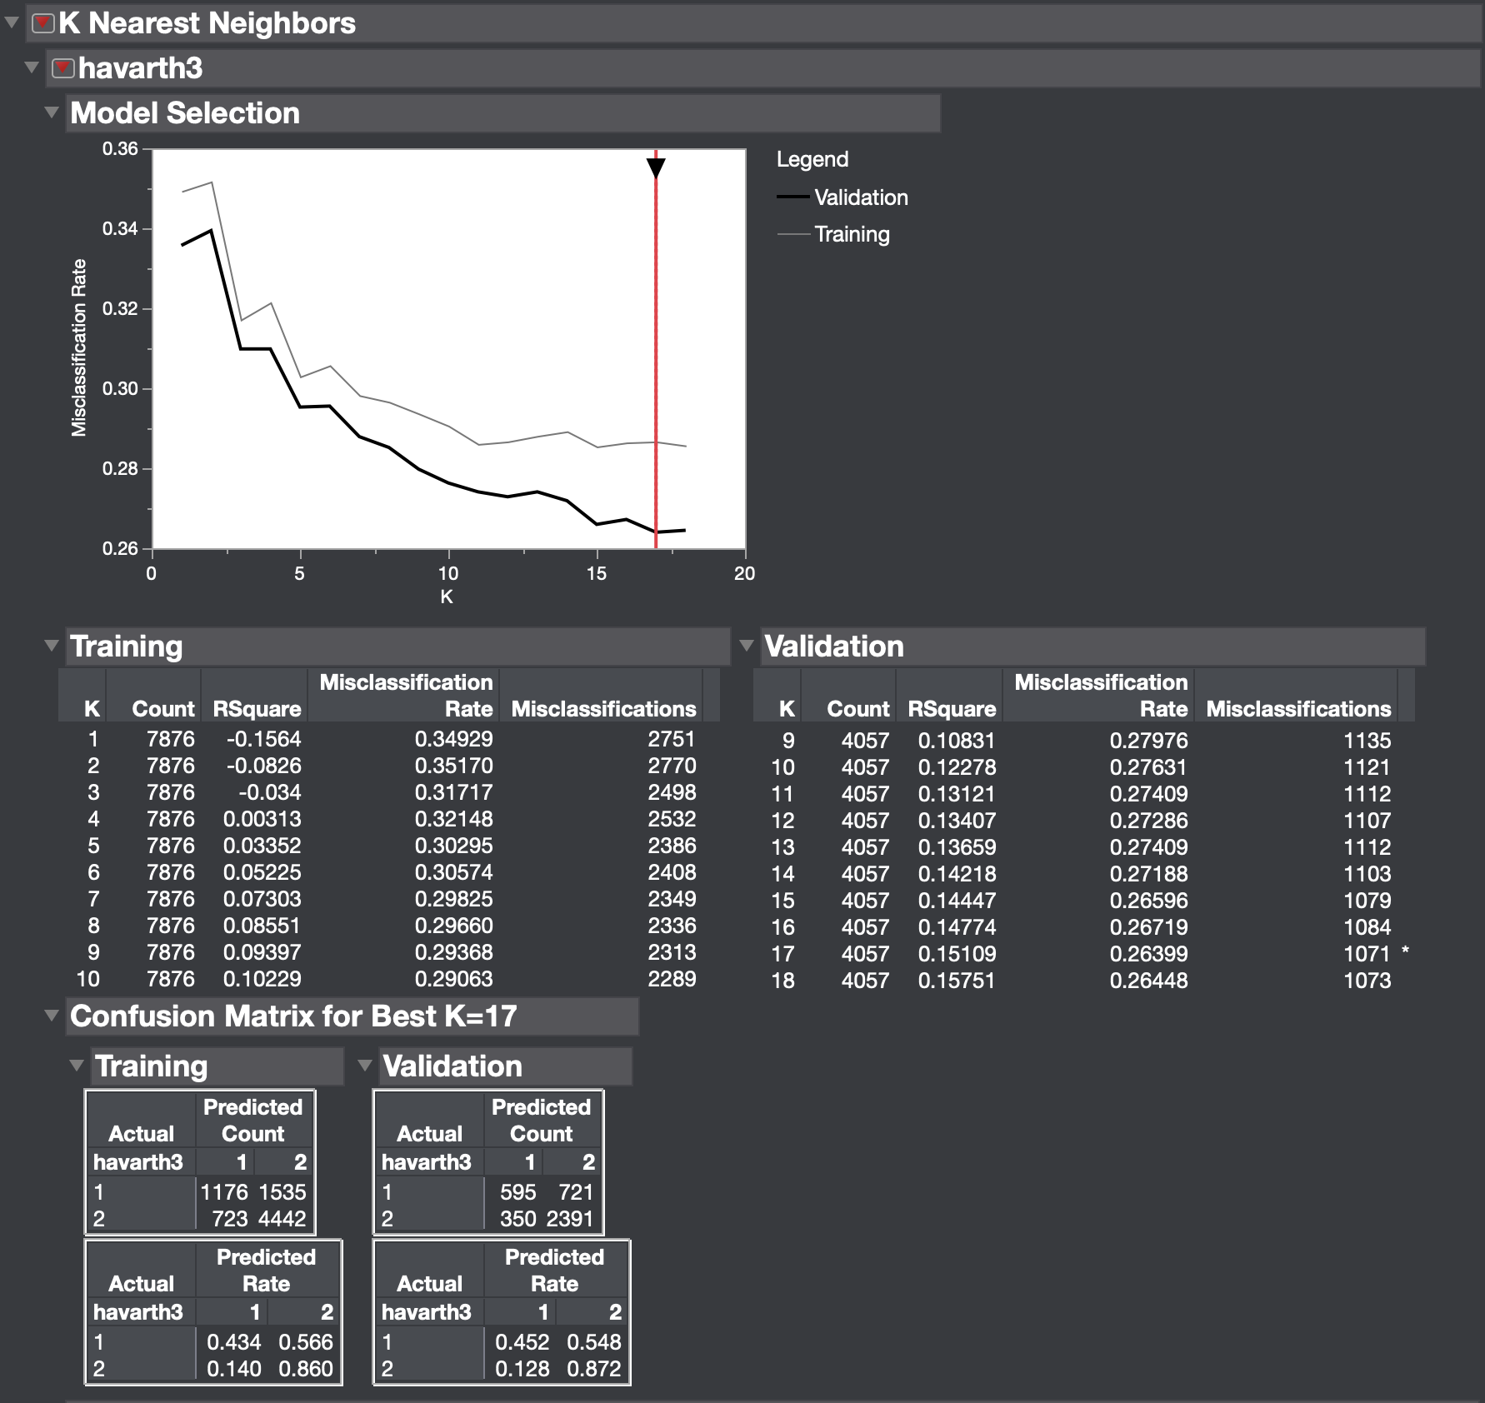

Class 1 TPR = 0.4521. Weighted average TPR for Class 1 = 0.1467. Class 2 TPR = 0.8723. Weighted average TPR for class 2 = 0.5893. Weighted combined average TPR for both classes =0.7360. FPR for class 1 = 0.1277. Weighted average FPR for class 1 = 0.0414. FPR for class 2 = 0.5479. Weighted average FPR for class 2 = 0.4115. Weighted combined average FPR for both classes =0.4116. Precision for class 1 = 0.6296. Weighted average precision for class 1 = 0.2042. Precision for class 2= 0.7683. Weighted average precision for class 2 = 0.5191. Weighted combined average precision for both classes = 0.7233. Recall for class 1 = TPR. Recall for class 2 = TPR. Weighted averages across all classes = same as TPR for Recall. F-measure of class 1 = 0.5263. Weighted average F-measure for class 1= 0.1707. F-measure for class 2= 0.8170. Weighted average F-measure for class 2 = 0.5520. Weighted combined average F-measure for both classes = 0.7227. MCC for class1 = 0.3593. Weighted average MCC for class 1 = 0.1165. MCC of class 2 = 0.3593. Weighted average MCC for class 2 = 0.2428. Weighted combined average MCC for both classes = 0.3593. K Nearest Neighbors does not include ROC curve option on JMP Pro.

Results Obtained using ReliefF Attribute Evaluator and Naïve Bayes Algorithm:

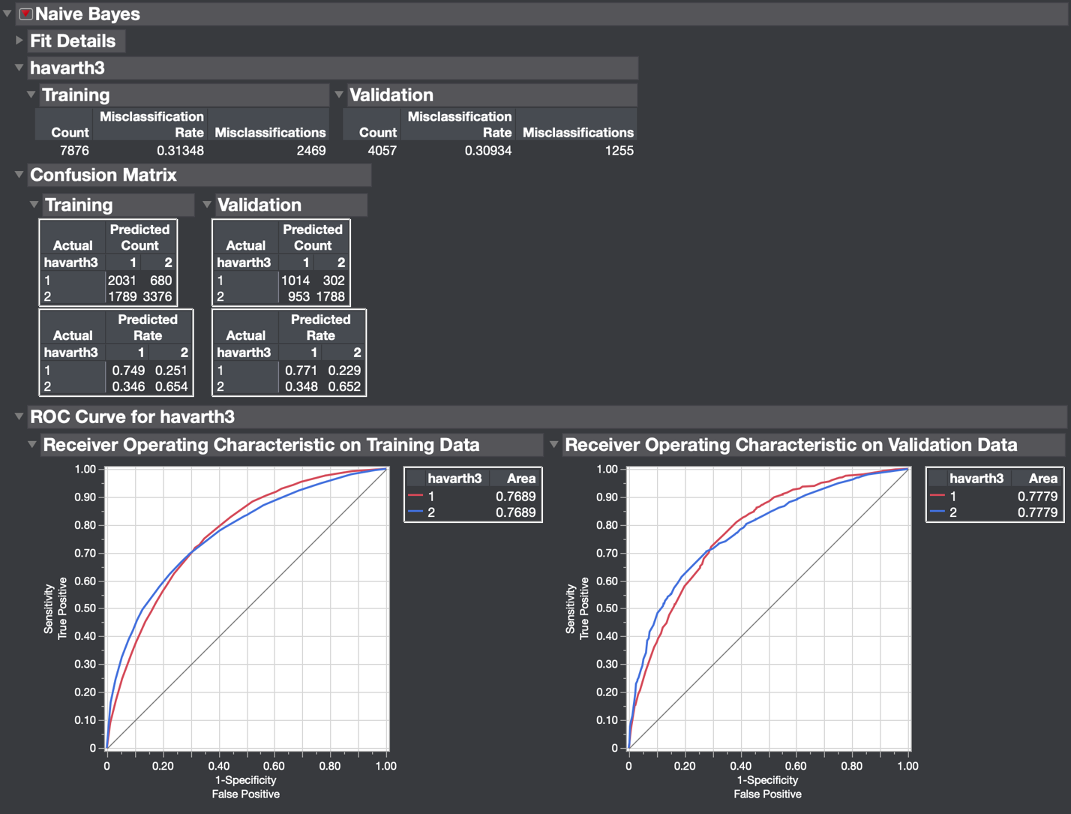

Class 1 TPR = 0.7711. Weighted average TPR for Class 1 = 0.2501. Class 2 TPR = 0.6523. Weighted average TPR for class 2 = 0.4407. Weighted combined average TPR for both classes =0.6908. FPR for class 1 = 0.3477. Weighted average FPR for class 1 = 0.1128. FPR for class 2 = 0.2295. Weighted average FPR for class 2 = 0.1550. Weighted combined average FPR for both classes =0.2678. Precision for class 1 = 0.5155. Weighted average precision for class 1 = 0.1672. Precision for class 2= 0.8555. Weighted average precision for class 2 = 0.5780. Weighted combined average precision for both classes = 0.7452. Recall for class 1 = TPR. Recall for class 2 = TPR. Weighted averages across all classes = same as TPR for Recall. F-measure of class 1 = 0.6179. Weighted average F-measure for class 1= 0.2004. F-measure for class 2= 0.7402. Weighted average F-measure for class 2 = 0.5001. Weighted combined average F-measure for both classes = 0.7005. MCC for class1 = 0.3966. Weighted average MCC for class 1 = 0.1286. MCC of class 2 = 0.3966. Weighted average MCC for class 2 = 0.2679. Weighted combined average MCC for both classes = 0.3966. Weighted average ROC area for class 1 = 0.2523. Weighted average ROC area for class 2 = 0.5256. Weighted combined average ROC area for both classes = 0.7779.

Results Obtained using ReliefF Attribute Evaluator and SVM Algorithm:

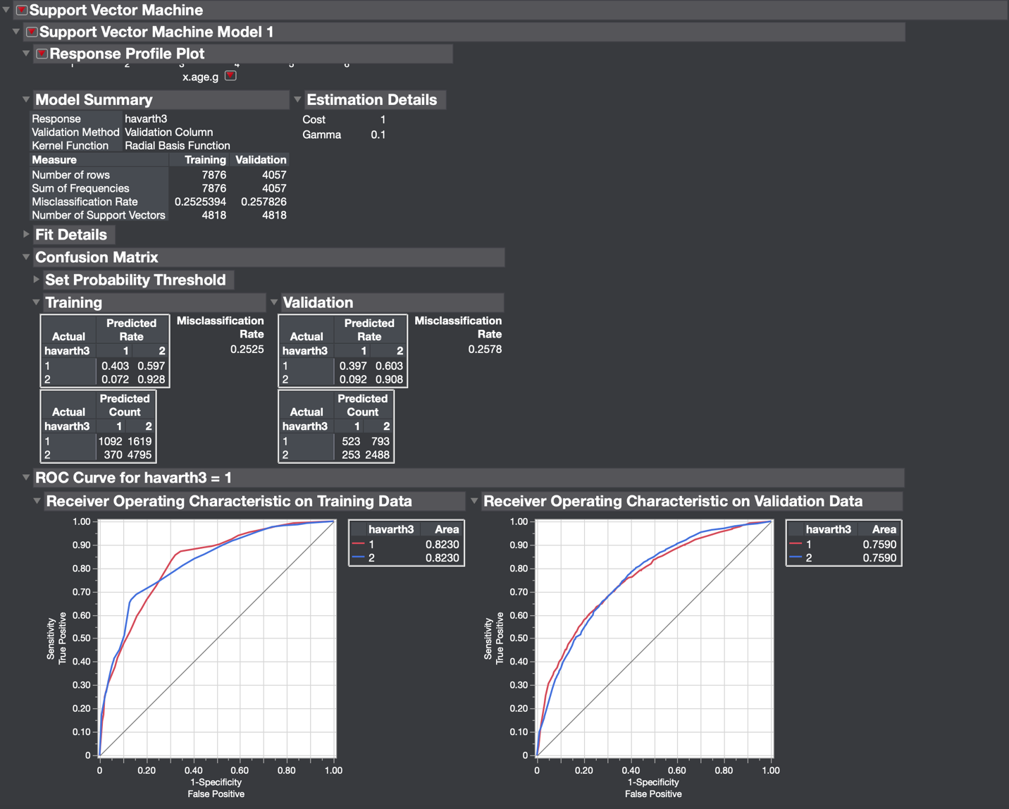

Class 1 TPR = 0.3974. Weighted average TPR for Class 1 = 0.1289. Class 2 TPR = 0.9077. Weighted average TPR for class 2 = 0.6133. Weighted combined average TPR for both classes = 0.7422. FPR for class 1 = 0.0923. Weighted average FPR for class 1 = 0.0299. FPR for class 2 = 0.6026. Weighted average FPR for class 2 = 0.4071. Weighted combined average FPR for both classes = 0.4370. Precision for class 1 = 0.6740. Weighted average precision for class 1 = 0.2186. Precision for class 2= 0.7583. Weighted average precision for class 2 = 0.5123. Weighted combined average precision for both classes = 0.7309. Recall for class 1 = TPR. Recall for class 2 = TPR. Weighted averages across all classes = same as TPR for Recall. F-measure of class 1 = 0.5. Weighted average F-measure for class 1= 0.1622. F-measure for class 2= 0.8263. Weighted average F-measure for class 2 = 0.5583. Weighted combined average F-measure for both classes = 0.7204. MCC for class1 = 0.3632. Weighted average MCC for class 1 = 0.1178. MCC of class 2 = 0.3632. Weighted average MCC for class 2 = 0.2454. Weighted combined average MCC for both classes = 0.3632. Weighted average ROC area for class 1 = 0.2462. Weighted average ROC area for class 2 = 0.5128. Weighted combined average ROC area for both classes = 0.7590.